|  |
| --- |
| User Manual  Samuda Commercial (Local) |
| REFERENCE: GW/ERP/USER MANUAL |
|  |
| **Genweb2 Ltd.** |
| **17-Aug-20** |



|  |
| --- |
|  |

# Document Information

|  |  |
| --- | --- |
| Document Name | User manual for Commercial (Local) |
| Document Author | Rashedul Alam |
| Document Version | 1.0 |
| Release Date | 17th Aug, 2020 |

|  |  |
| --- | --- |
| Review by | Md. Mahfuzur Rahman |
| Review Date | 16th Aug, 2020 |
| Approved By |  |
| Approval Date |  |

# Document History

|  |  |  |  |  |  |
| --- | --- | --- | --- | --- | --- |
| A=Added, M=Modified, D=Delete | | | | | |
| **Version No** | **Date** | **Section No** | **A/M/D** | **Description of Change** | **Author** |
| 1.0 | 12-Aug-2020 |  | A | Initial | Rashedul Alam |
| 1.1 | 16-Aug-2020 |  | A/M | Feedback incorporate, Some reports add, new image add & Some text modify | Rashedul Alam |

Contents

A. Document Information 2

B. Document History 2

1. Introduction 4

1.1. Purpose of User manual 4

1.2 Sales order (Local) View by Commercial user/Manager 4

1.3 Approved PI (Local) View by Commercial user/Manager 5

1.4 Commercial invoice view by Commercial user/Manager 6

2. Export LC (local) 6

2.1 Export LC (local) creation by Commercial user/Manager 6

2.2 Confirm Export LC (local) by Commercial user/Manager 9

2.3 Amendment creation by Commercial User/Manager 9

2.4 Create Shipment by Commercial User/Manager 11

2.5 Shipment Cancel by Commercial User/Manager 12

2.6 Create Delivery by Commercial User/Manager 13

2.7 Add Invoice by Commercial user/Manager 15

2.8 TO Sales create by Commercial User/Manager 15

2.9 TO Buyer create by Commercial User/Manager 17

2.10 TO Seller Bank create by Commercial User/Manager 19

2.11 TO Buyer Bank create by Commercial User/Manager 21

2.12 TO Maturity create by Commercial User/Manager 23

2.13 Shipment done by Commercial Manager 25

2.14 Additional info input by Commercial Manager 27

2.15 Terms & Condition input by Commercial Manager 29

2.16 LC document input by Commercial Manager 30

2.17 LC done by Commercial Manager 31

3. Reports 33

3.1 First Acceptance reports view by Commercial Manager 33

3.2 Second Acceptance reports view by Commercial Manager 33

3.3 Maturity reports view by Commercial Manager 34

3.4 Bank Forwarding reports view by Commercial Manager 35

3.5 Commercial invoice reports view by Commercial Manager 36

3.6 Packing list reports view by Commercial Manager 36

3.7 Measurement list reports view by Commercial Manager 37

3.8 Bill of Exchange (First) reports view by Commercial Manager 37

3.9 Bill of Exchange (Second) reports view by Commercial Manager 38

3.10 Beneficiary certificate reports view by Commercial Manager 38

3.11 Inspection Certificate reports view by Commercial Manager 39

3.12 Certificate of Origin reports view by Commercial Manager 39

3.13 Delivery Challan reports view by Commercial Manager 40

3.14 Truck receipt/Delivery challan reports view by Commercial Manager 40

3.15 Party receiving reports view by Commercial Manager 41

# 1. **Introduction**

The purposes of this User manual are to clearly identify the customer requirements and provide a detailed document. The customer will read this document and get a clear view the sales module. It will also help the review team to validate whether the customer requirements have been fulfilled or not.

## 1.1. Purpose of User manual

This document is the User Manual of Commercial. It is intended to provide all the necessary information to use this software to develop application software running on the workstation.

## 1.2 Sales order (Local) View by Commercial user/Manager

Commercial user is able to view all approve SO & he/she is also able to view search using with SO & PI number.

Commercial users can view Approve SO using the menu **Commercial ‣ Sales ‣ Sales orders (Local)** and click

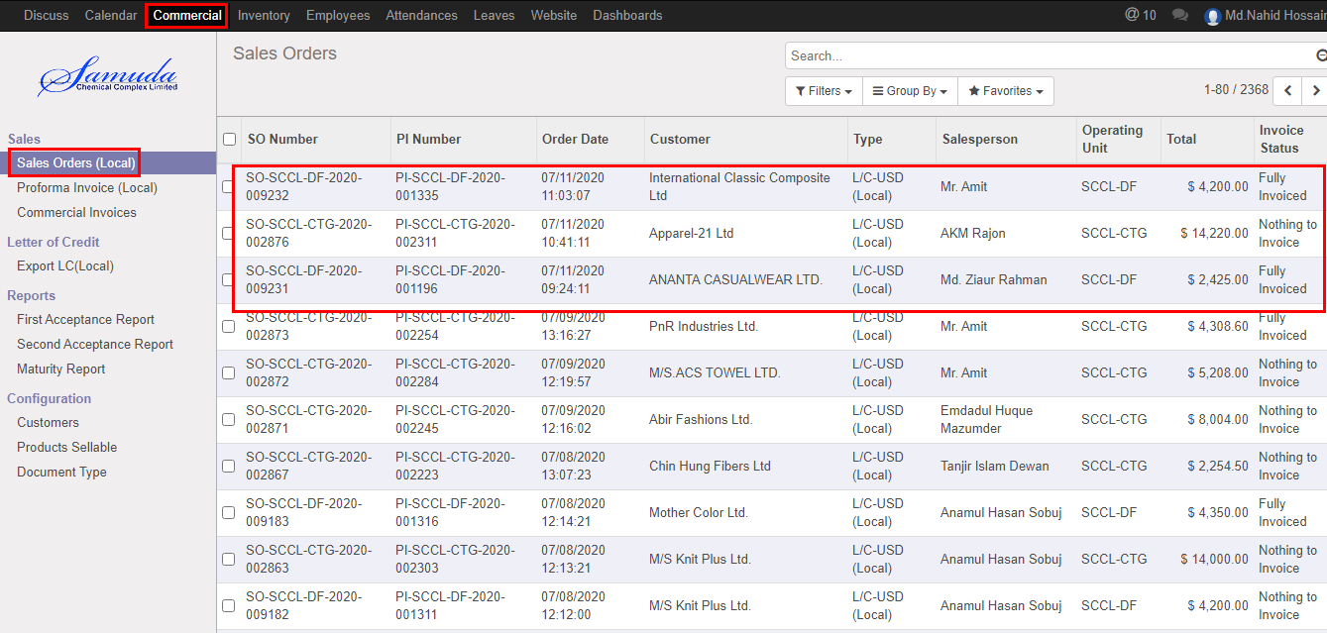

Figure: Approved SO (local) List view

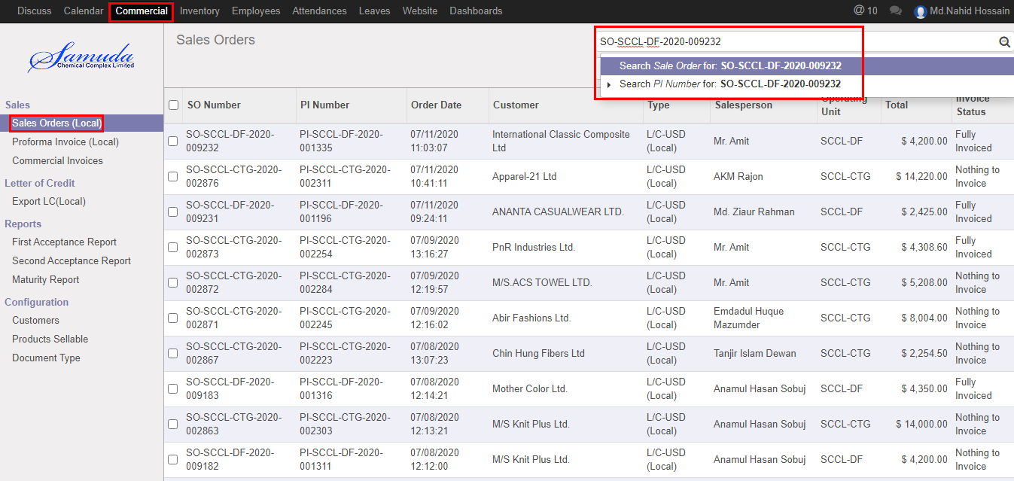

Figure: Sales Orders (Local) Search view

## 1.3 Approved PI (Local) View by Commercial user/Manager

Approve PI will view by Commercial user.

Commercial users can View Approve PI using the menu **Commercial ‣ Proforma Invoice (Local)** and click

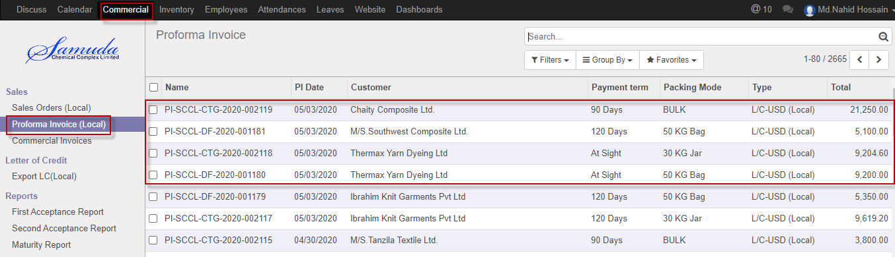

Figure: Approved PI (local) List view

## 1.4 Commercial invoice view by Commercial user/Manager

Commercial invoice will be view by Commercial user.

Commercial users can View commercial invoice using the menu **Commercial ‣ sales ‣ Commercial invoices** and click

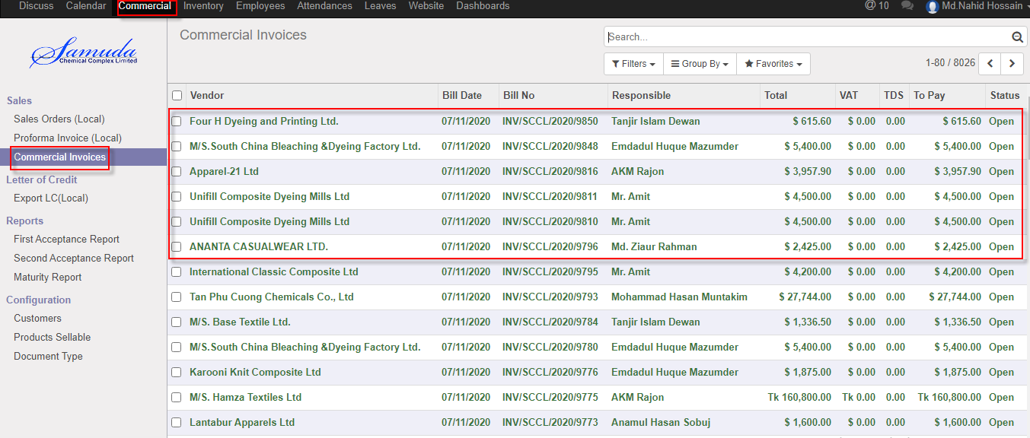

Figure: Commercial invoice List view

# 2. Export LC (local)

Letter of credit (LC) is two type Local or foreign .Here we will show Export LC local process which is similar to Export LC (Foreign)

## 2.1 Export LC (local) creation by Commercial user/Manager

Export LC (local) will be created/Edit by Commercial user.

Commercial user can create Export LC (local) using the menu **Commercial ‣ Letter of Credit> Export LC (Local)** and click **Create.**

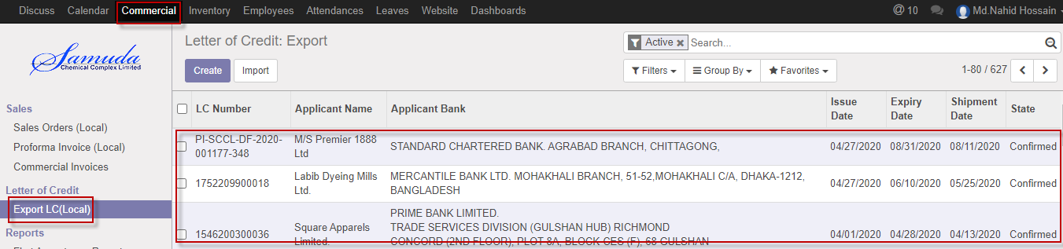

Figure: Export LC (local) List view

We need to set the following:-

**Proforma Invoice**: Select Proforma invoice. Multiple Proforma invoice select will possible here and after select all product list will come in product caption

**LC number:** Enter a LC number.

**Region type:** Region type will come auto after select Proforma invoice.

**Tenure:** Enter Tenure.

**Description:** Enter description.

**Beneficiary:** Beneficiary will come auto after select Proforma invoice**.**

**Bank account:** Bank account will come auto after select Proforma invoice.

**Applicant:** Applicant will come auto after select Proforma invoice**.**

**Bank Details:** Enter bank details**.**

**LC value:** LC value will come auto after select proforma invoice**.**

**Currency:** Currency will come auto.

**Tolerance:** Enter tolerance.

**Issue date:** Select issue date.

**Expiry date:** Select Expiry date.

**Shipment date:** Select shipment date.

**Additional info:** Additional info will fill-up if require.

**Product info:** Product info will come auto after select proforma invoice.

**LC Document:** LC Document will list here if needed.

**Attachment:** Attachment will be uploaded here if needed.

**Shipment:** Shipment will be listed shipment tab after shipment creations.

**Amendment:** Amendment will be listed amendment tab after amendment creations.

After entering all information click **Save & Open**.

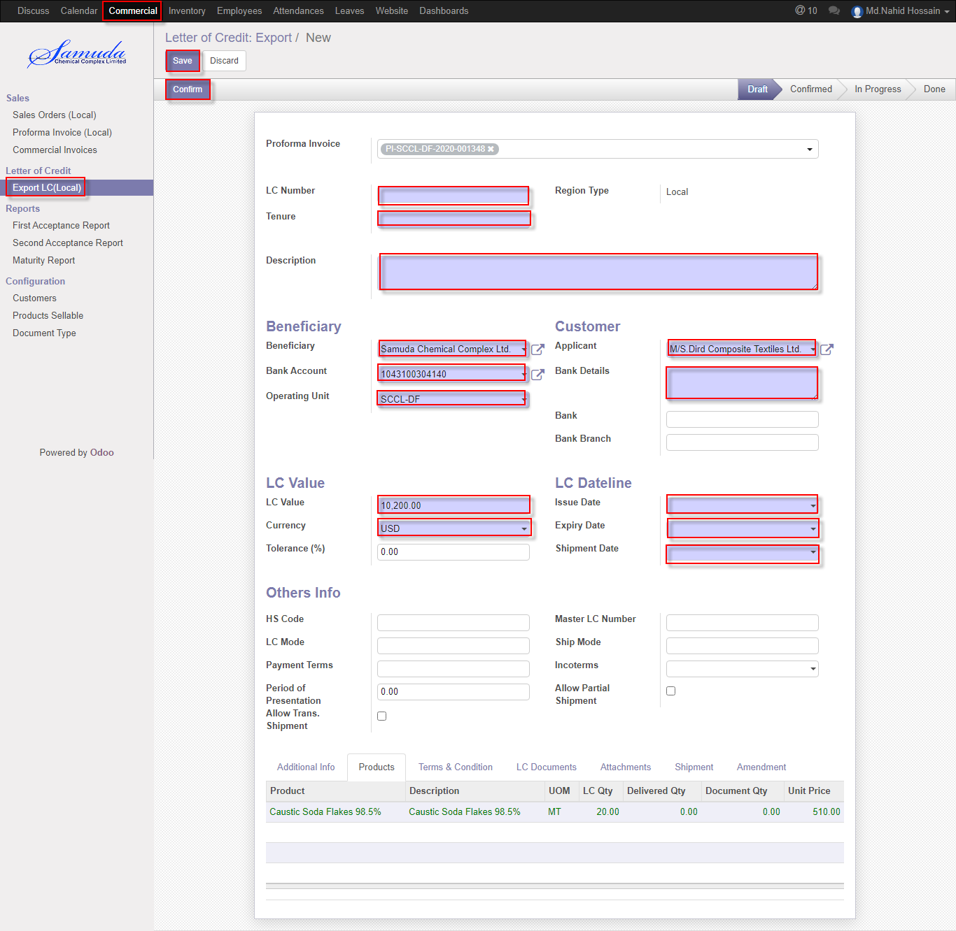

Figure: Export LC (local) creation

## 2.2 Confirm Export LC (local) by Commercial user/Manager

Export LC (local) will be confirmed by Commercial user or Manager Click **Confirm** button

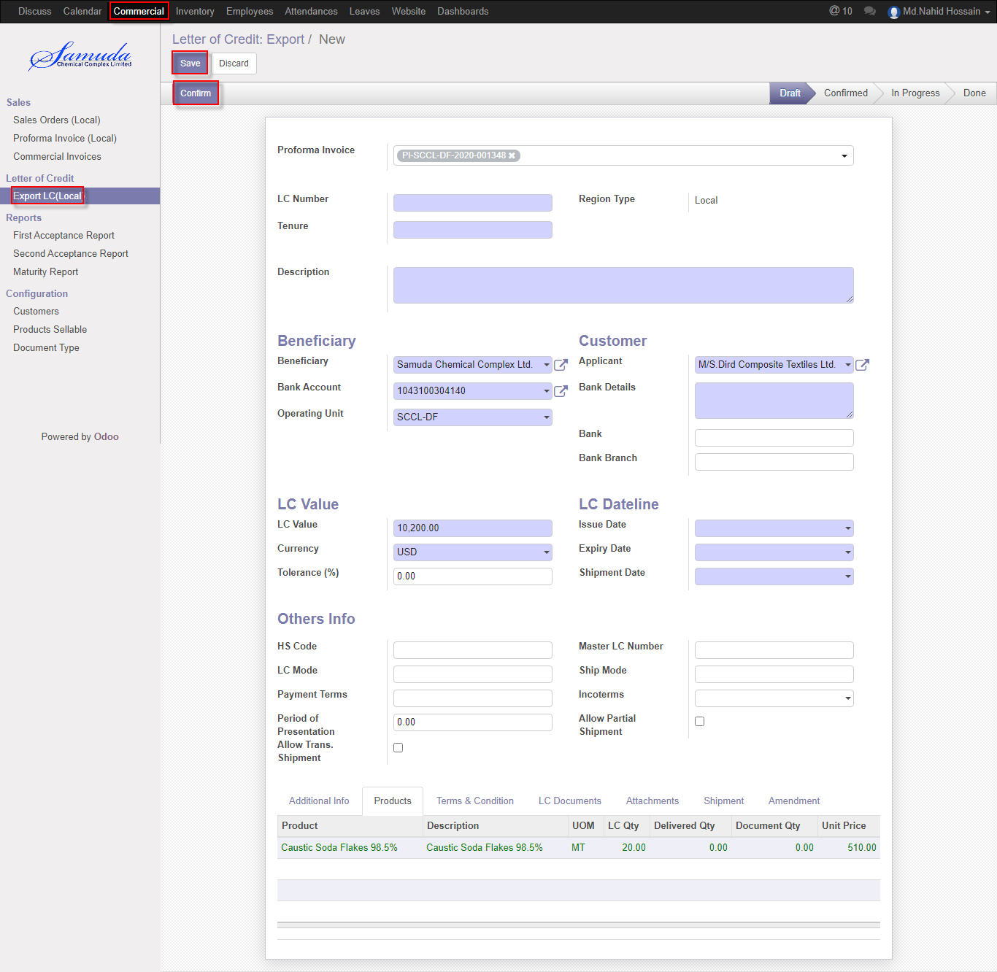

Figure: Export LC (local) Confirm

## 2.3 Amendment creation by Commercial User/Manager

Amendment will be Confirm by Commercial user/Manager click **Amendment** button.

Amendment should be multiple and after save it will load to amendment tab.

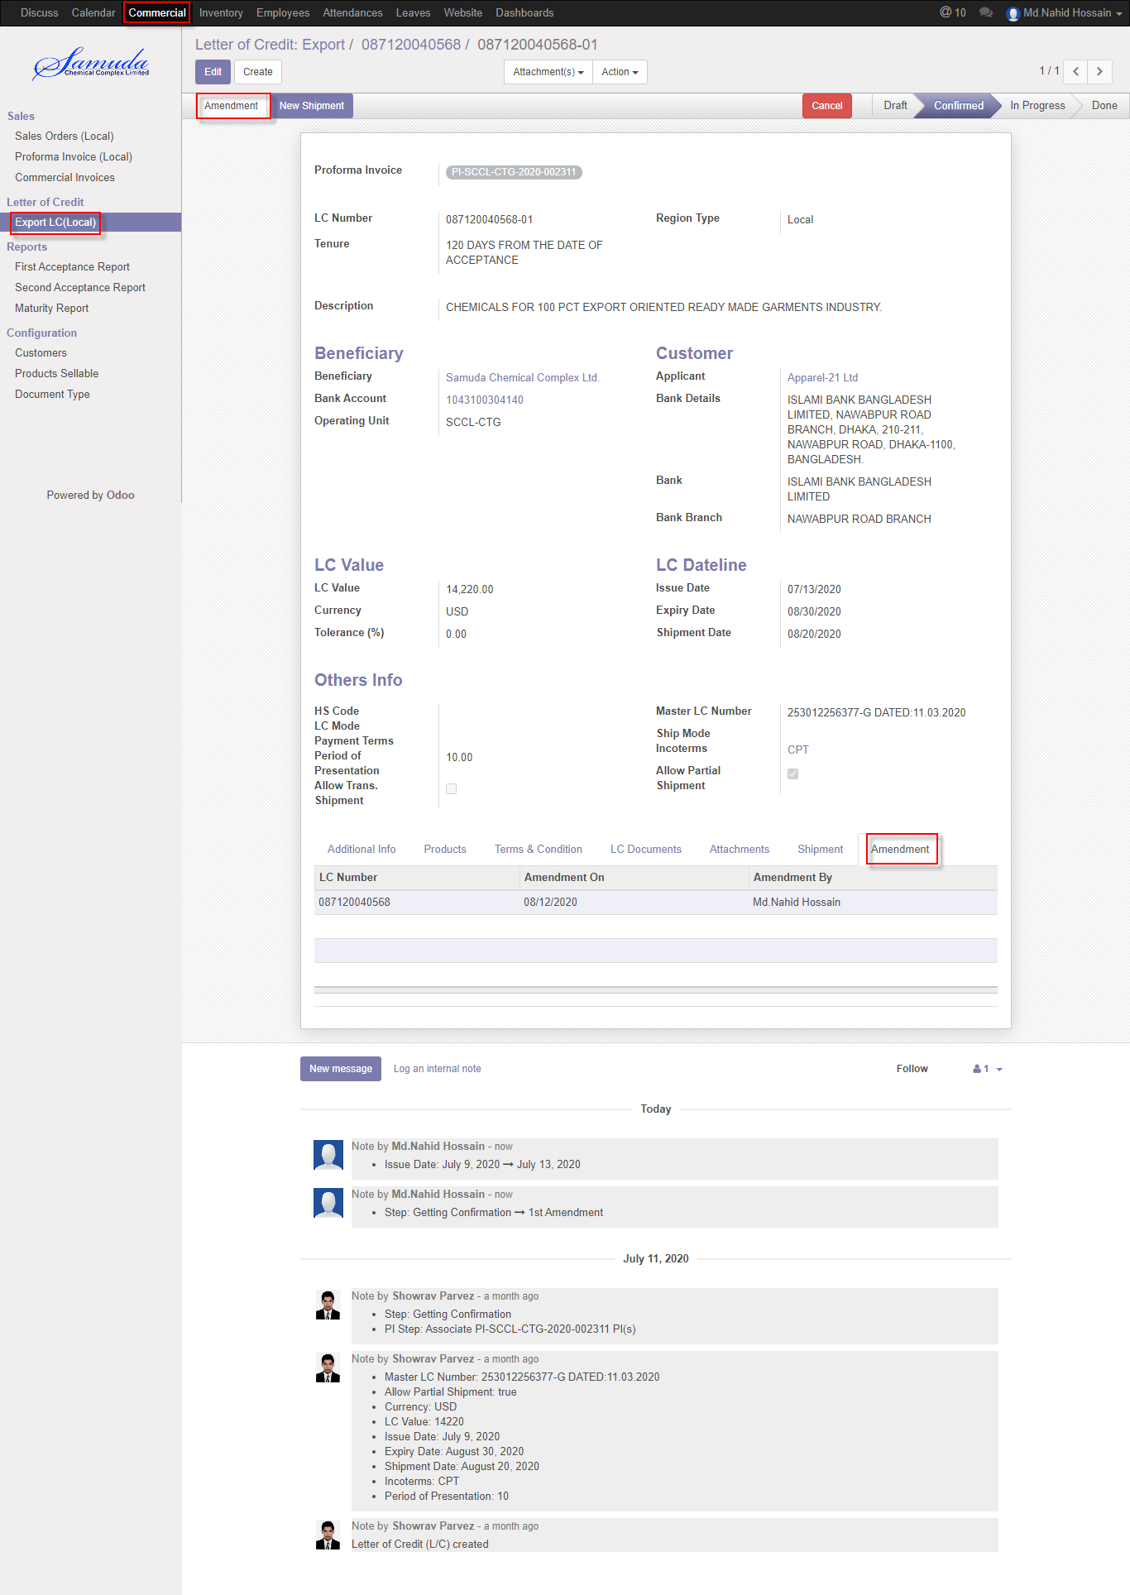

Figure: Amendment creation

## 2.4 Create Shipment by Commercial User/Manager

Shipment will be confirmed by Commercial user/Manager click **New Shipment** button

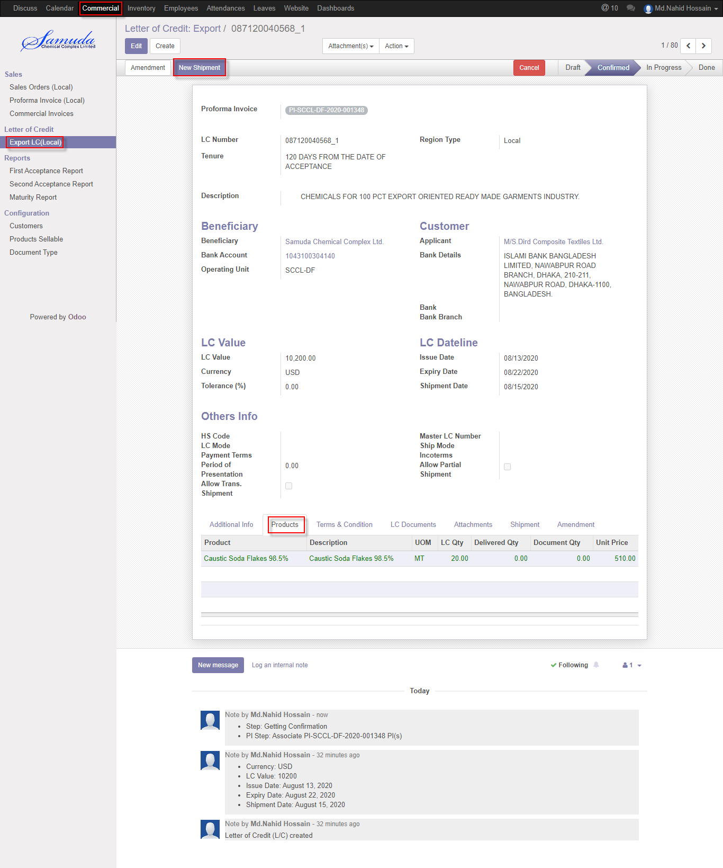

Figure: Create shipment

## 2.5 Shipment Cancel by Commercial User/Manager

Shipment will be canceled by Commercial user/Manager click **Cancel** button

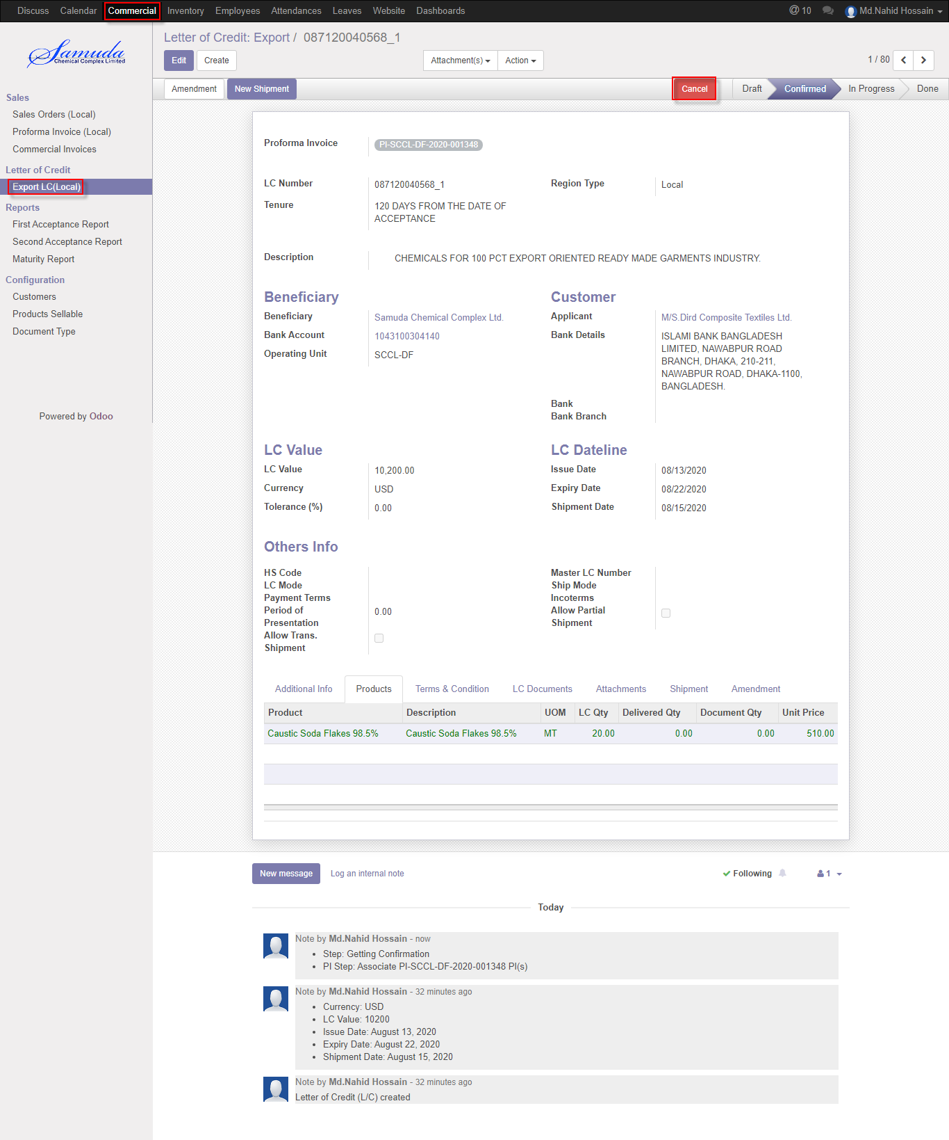

Figure: Cancel Shipment

## 2.6 Create Delivery by Commercial User/Manager

Delivery will be created by Commercial user/Manger click on **Delivery** button

We need to set the following:-

**Number:** Enter a number.

**Invoice Value:** Invoice value will come auto after select invoice from Invoice window.

**Transport By:** Enter Transport By.

**Vehicle No:** Enter Vehicle No.

**Freight:** Enter freight.

**Gross Weight:** Enter gross weight.

**Net Weight:** Enter Net weight.

**Weight Unit:** Select weight unit.

**Total (Jar/Drum/Bag/Balk):** Select Jar/Drum/Bag/Bulk

After entering all information click **Save & Delivery**.

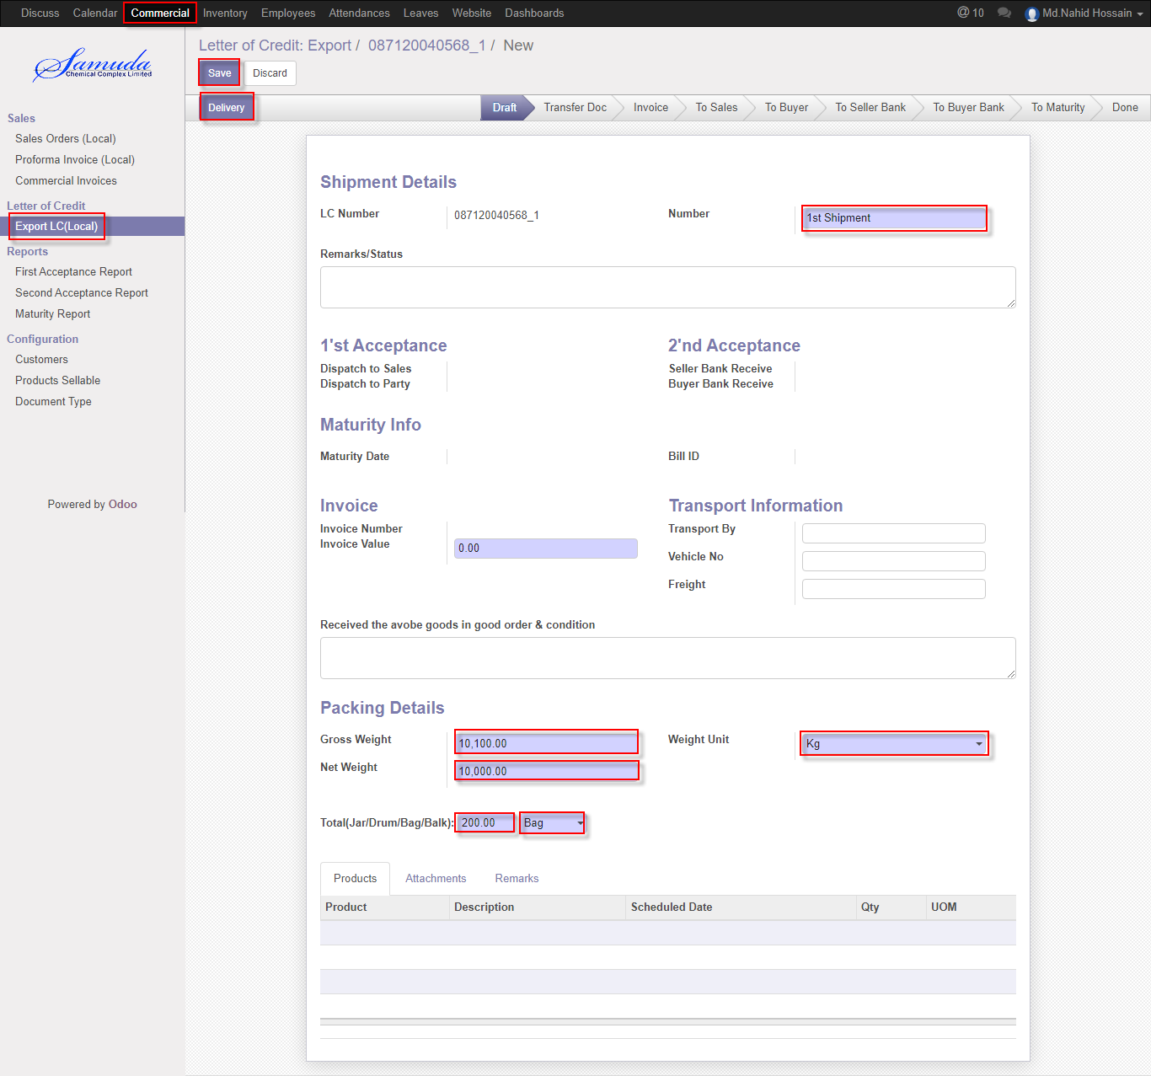

Figure: Create Delivery

A Product Shipment Window will appear after click on Delivery button for given shipment qty. Then enter shipment qty and **Save**

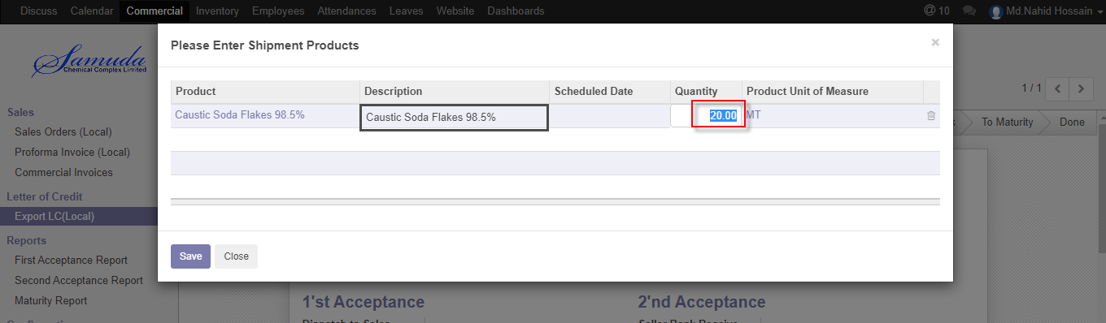

Figure: Shipment Product window

## 2.7 Add Invoice by Commercial user/Manager

Add invoice will be added by Commercial user/Manager click **Add invoice** button

We need to set the following:-

**Invoice Number:** Select Invoice number.

**Invoice Value:** Invoice value will come auto after select invoice number.

After entering all information click **Save**

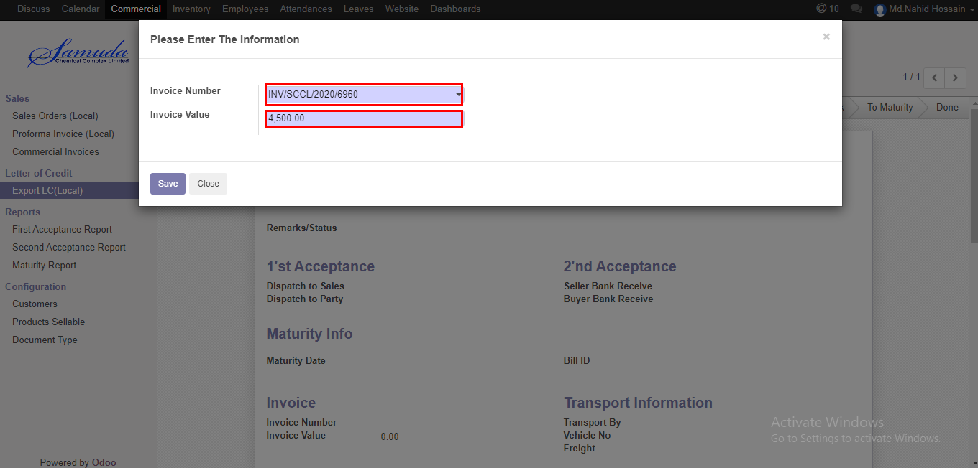

Figure: Create Add invoice

## 2.8 TO Sales create by Commercial User/Manager

To Sales will be created by Commercial User/Manager click **To Sales** button

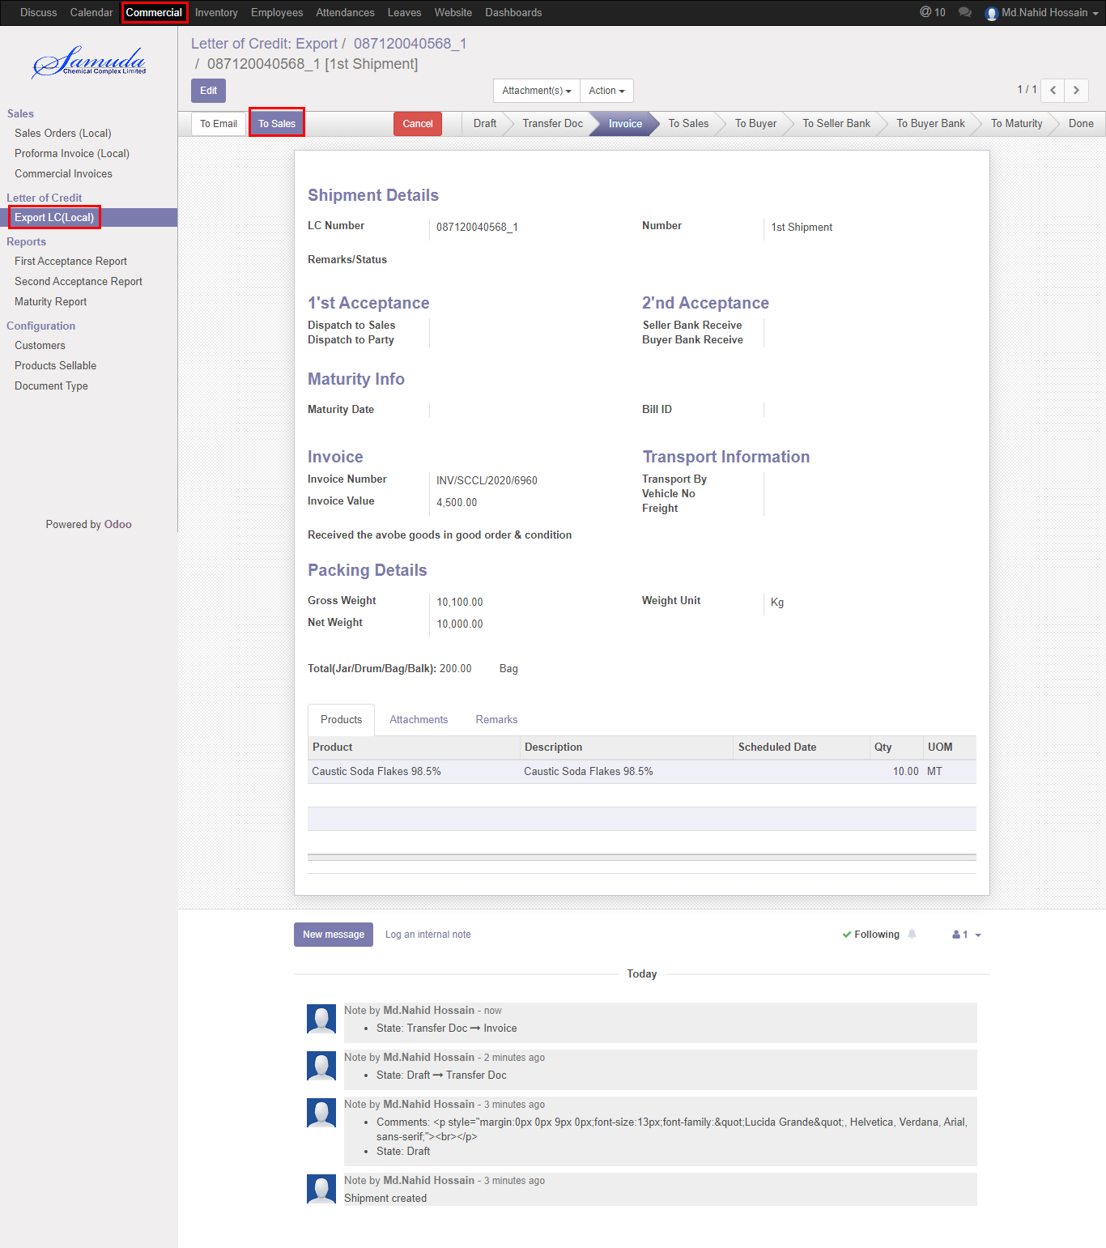

Figure: Created To Sales

Below window will open after click the To Sales button 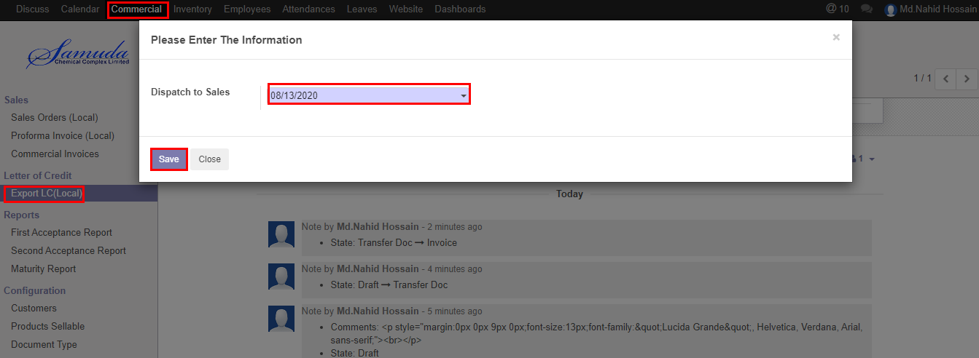

Figure: Dispatch To Sales

We need to set the following:-

**Dispatch To Sales**: Select date.

After entering all information click **Save**.

## 2.9 TO Buyer create by Commercial User/Manager

To Buyer will be created by Commercial User/Manager click **To Buyer** button

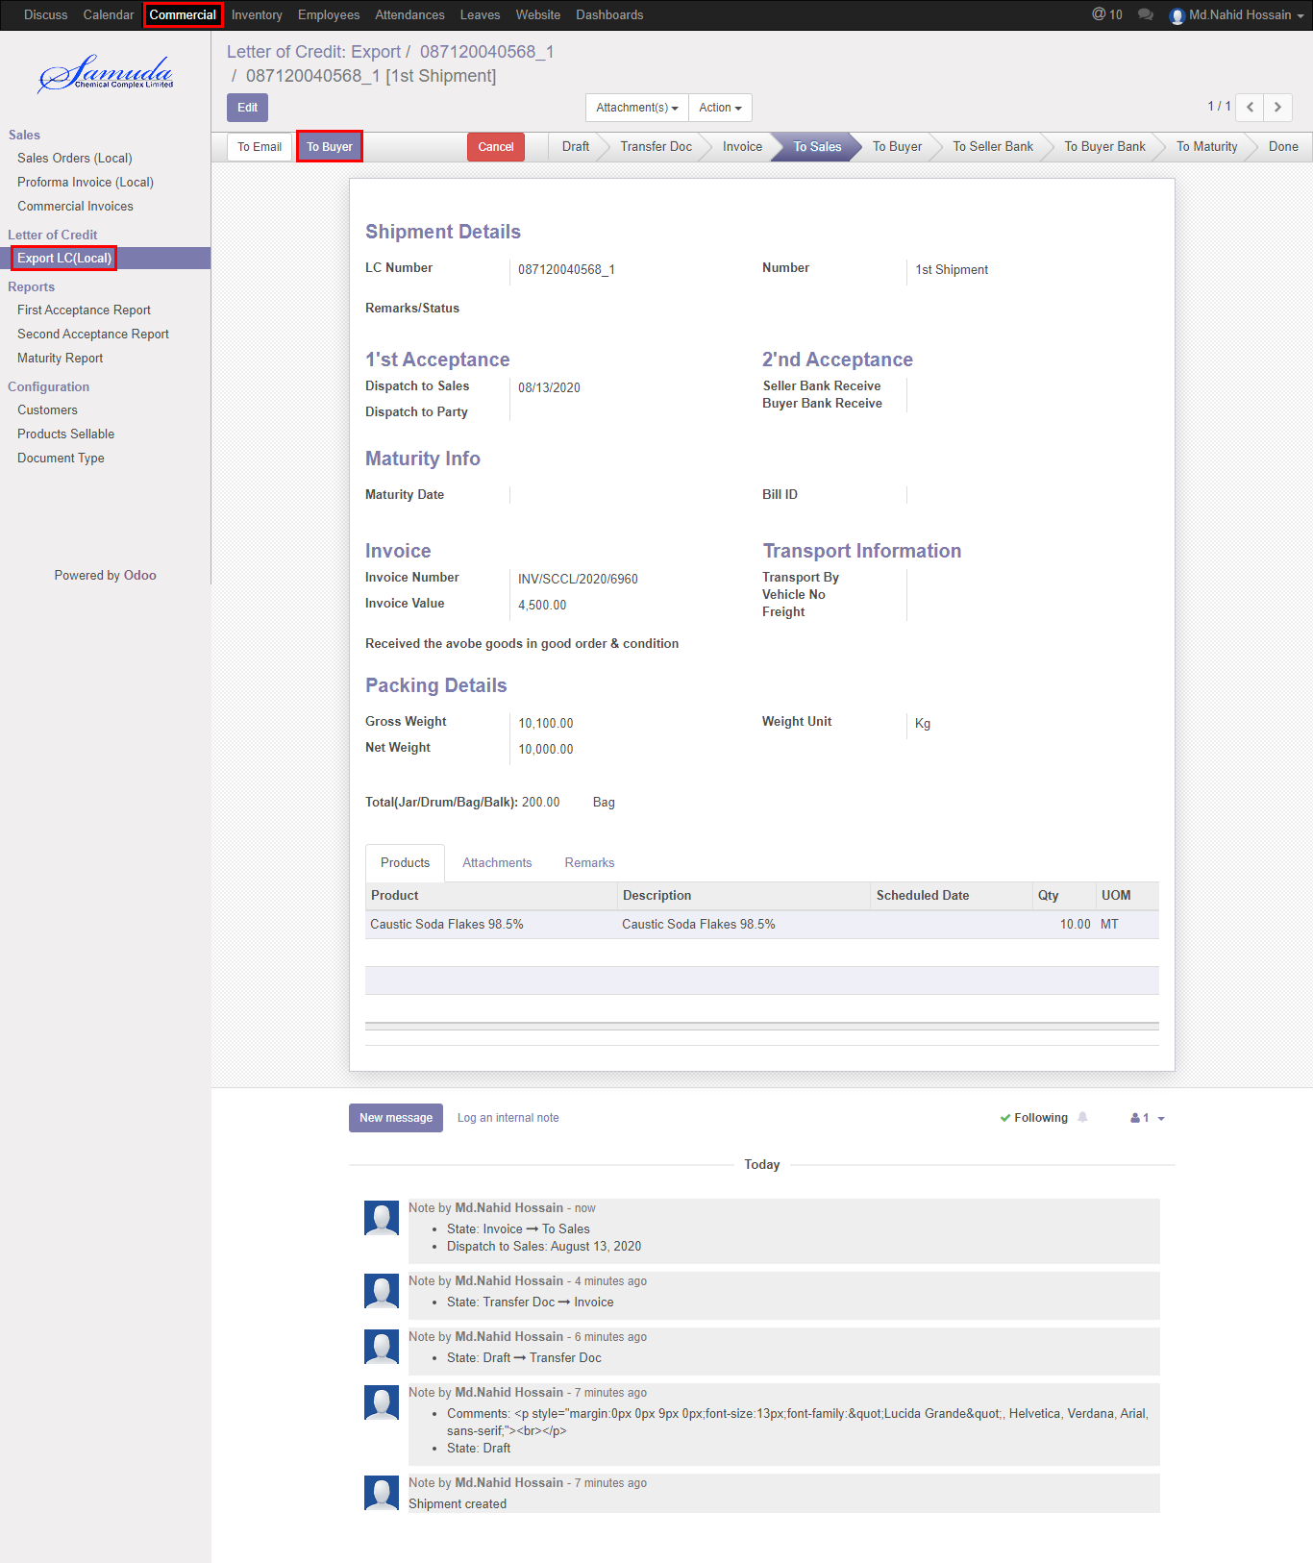

Figure: Created To Buyer

Below window will open after click the To Buyer button 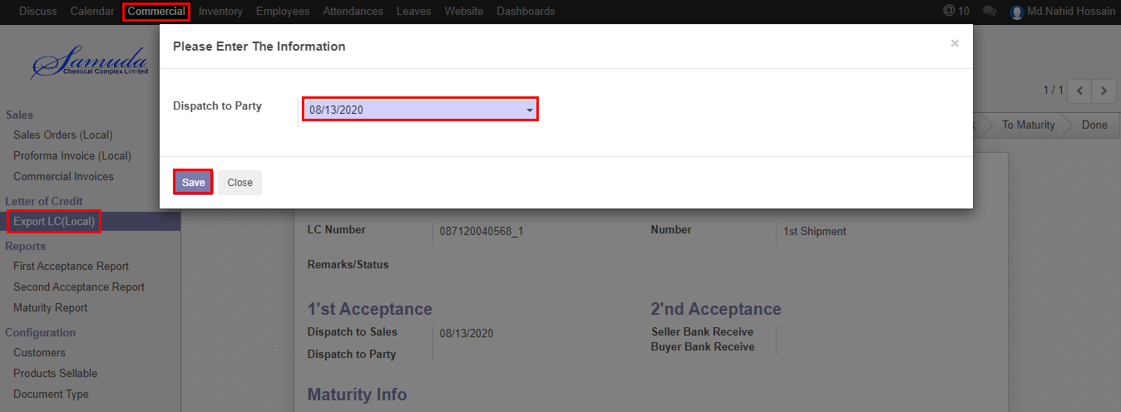

Figure: Dispatch To Party

We need to set the following:-

**Dispatch To Party**: Select date.

After entering all information click **Save**.

## 2.10 TO Seller Bank create by Commercial User/Manager

To Seller Bank will be created by Commercial User/Manager click **To Seller Bank** button

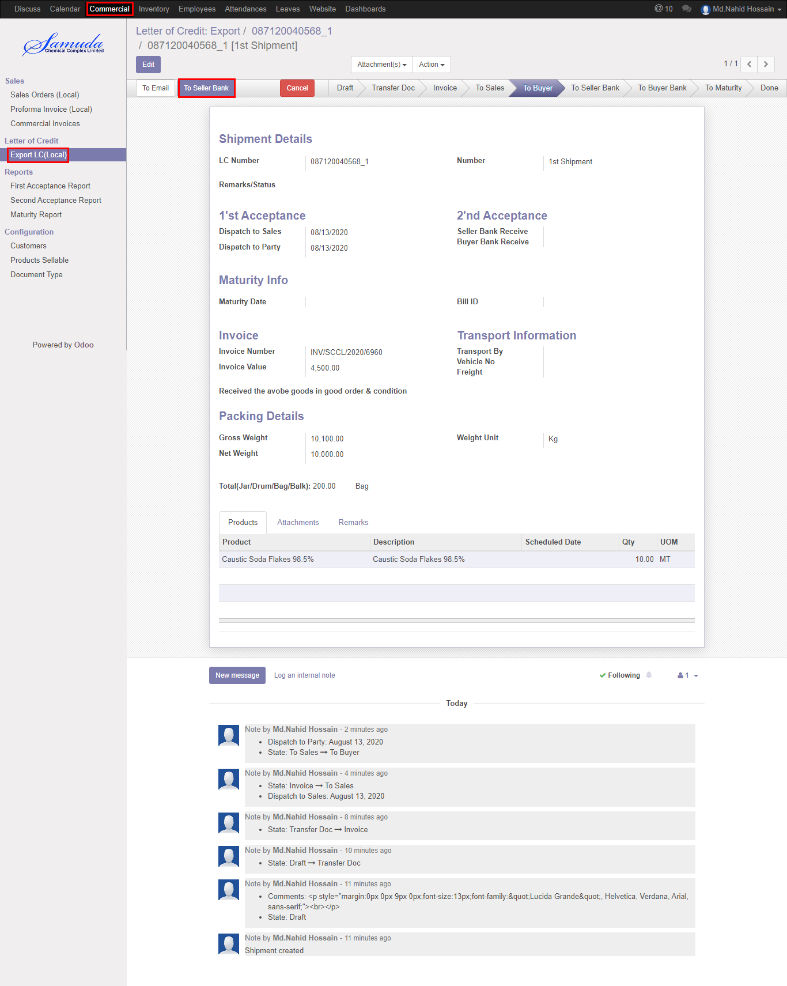

Figure: Created To Seller Bank

Below window will open after click the To Seller Bank button 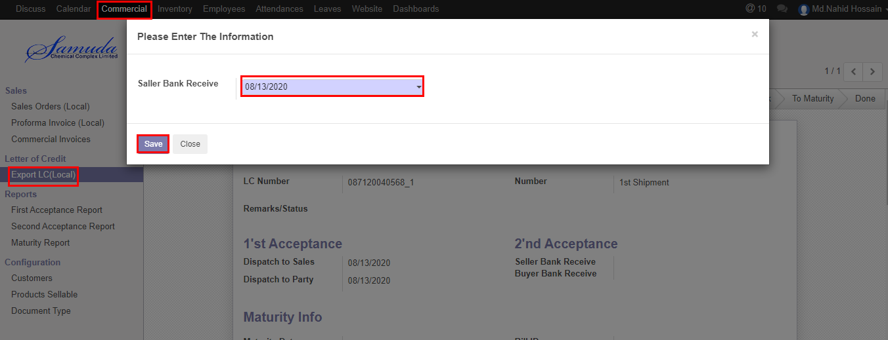

Figure: Seller Bank Receive

We need to set the following:-

**Seller Bank Receive**: Select date.

After entering all information click **Save**.

## 2.11 TO Buyer Bank create by Commercial User/Manager

To Buyer Bank will be created by Commercial User/Manager click **To Buyer Bank** button

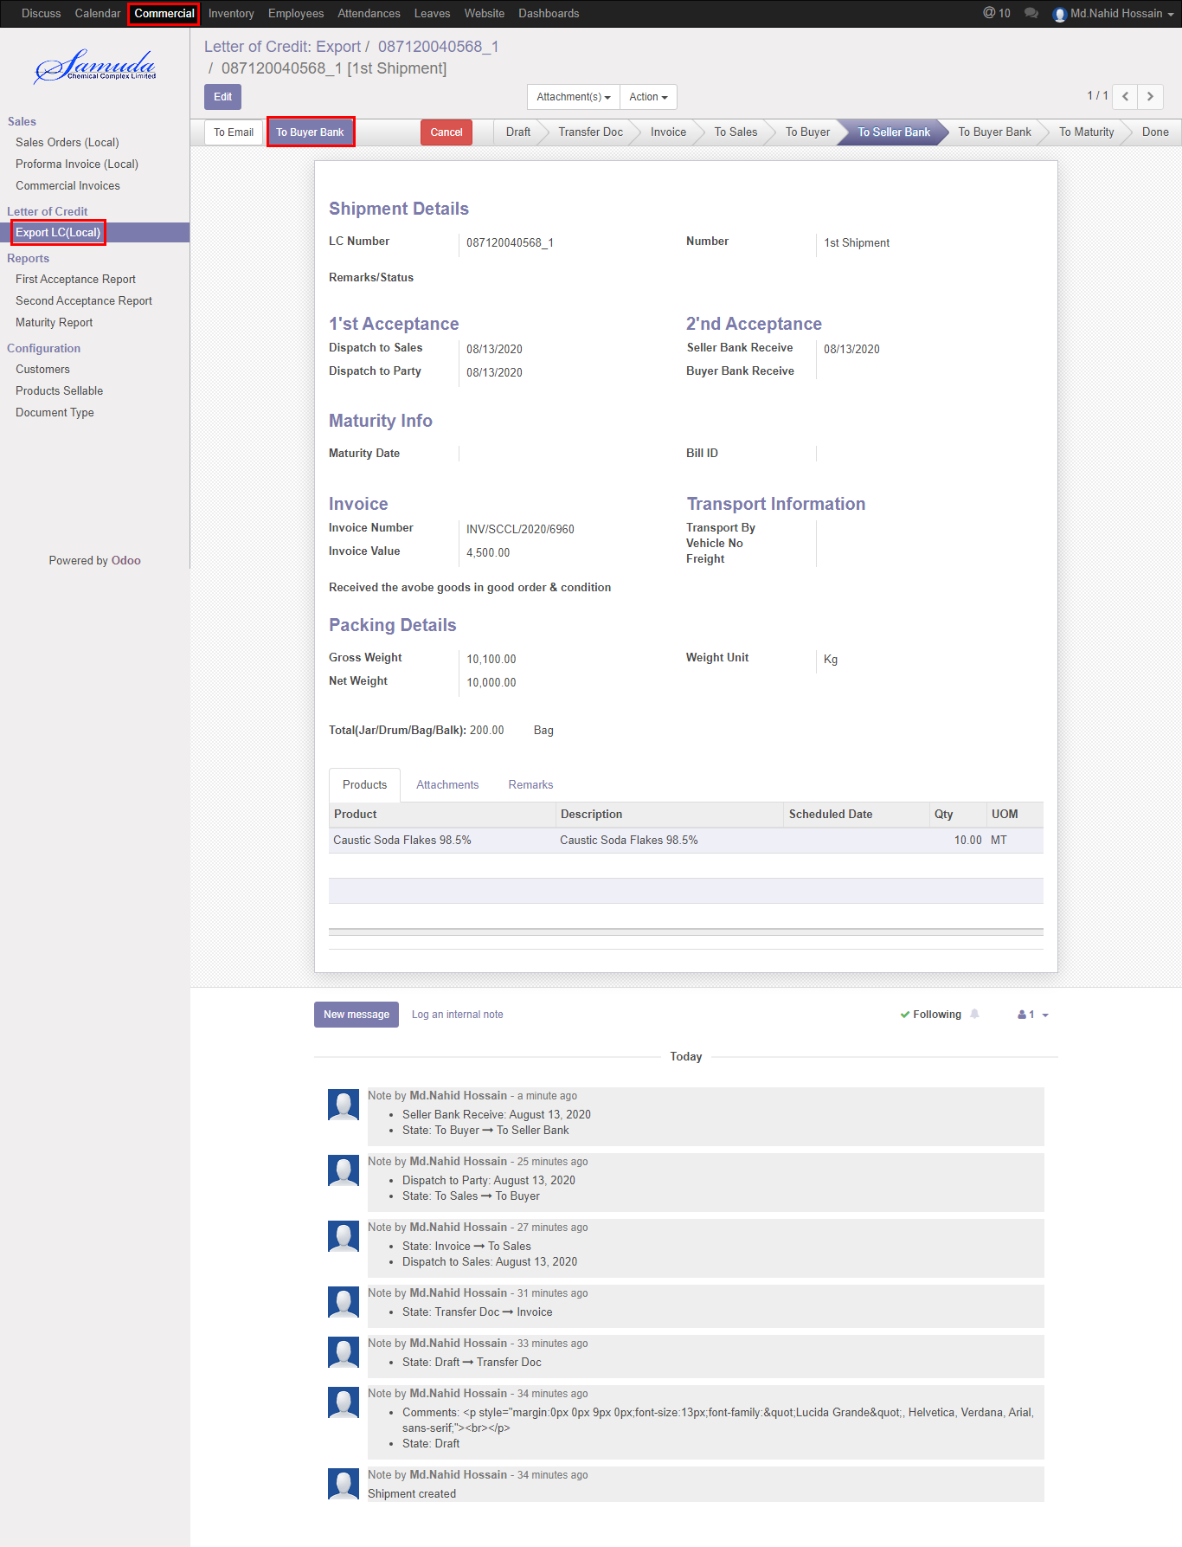

Figure: Created To Buyer Bank

Below window will open after click the To Buyer Bank button 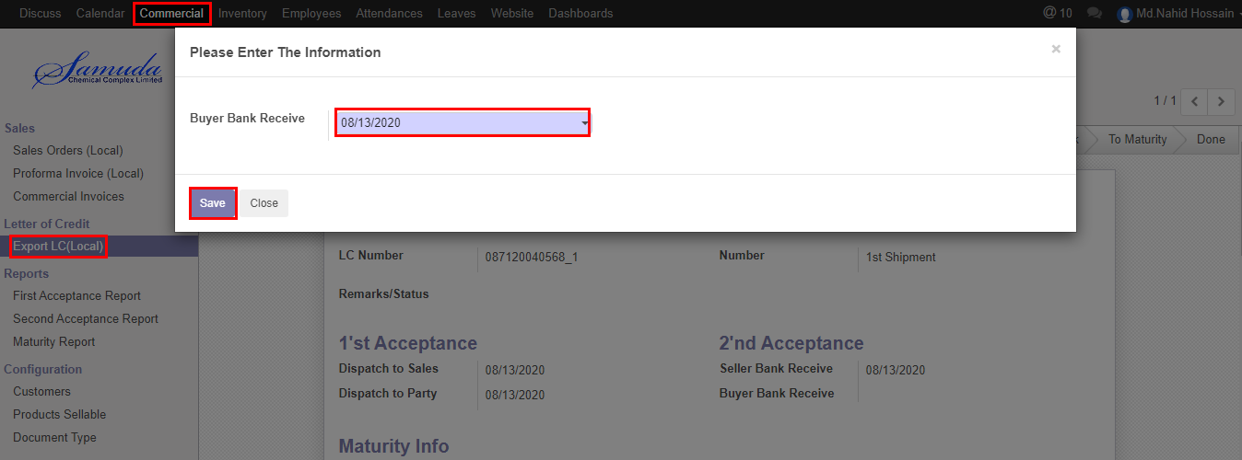

Figure: To Buyer Bank Receive

We need to set the following:-

**Buyer Bank Receive**: Select date.

After entering all information click **Save**.

## 2.12 TO Maturity create by Commercial User/Manager

To Maturity will be created by Commercial User/Manager click **To Maturity** button

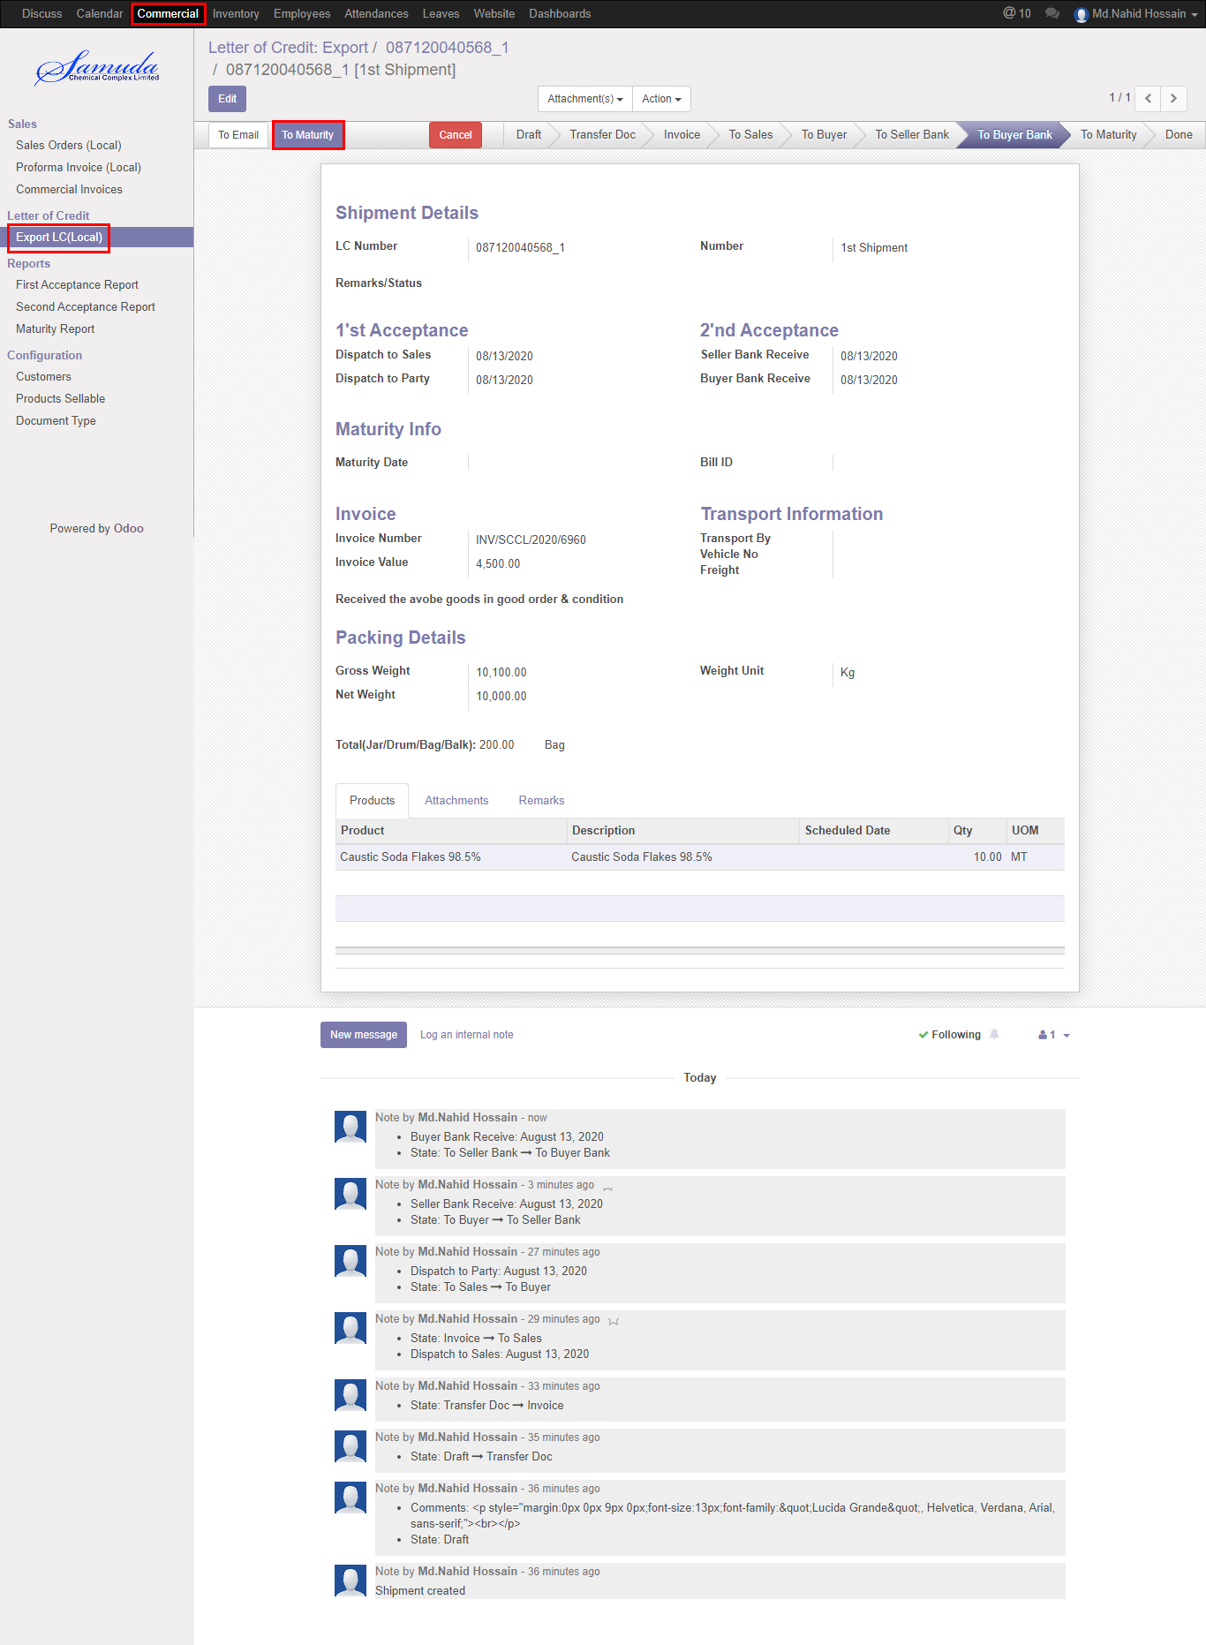

Figure: Created To Maturity

Below window will open after click the To Maturity button 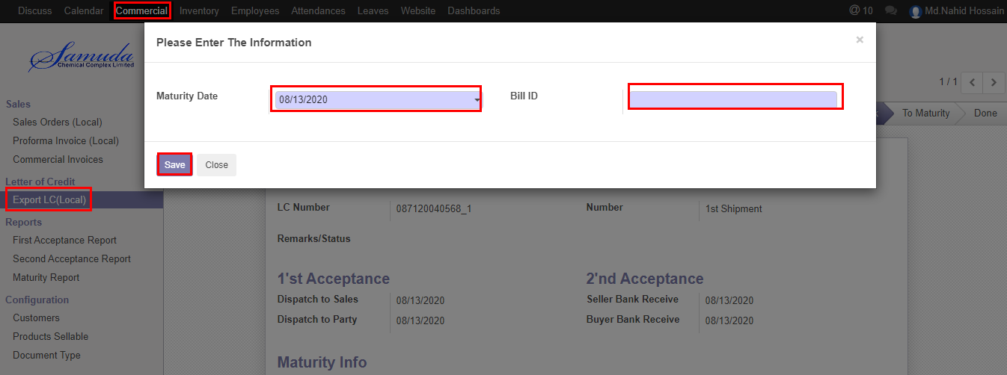

Figure: To Maturity

We need to set the following:-

**Maturity Date**: Select date.

**Bill ID**: Enter bill ID.

After entering all information click **Save**.

## 2.13 Shipment done by Commercial Manager

Shipment done state will come after To Maturity completed. Commercial Manager Shipment will done by click **done** button

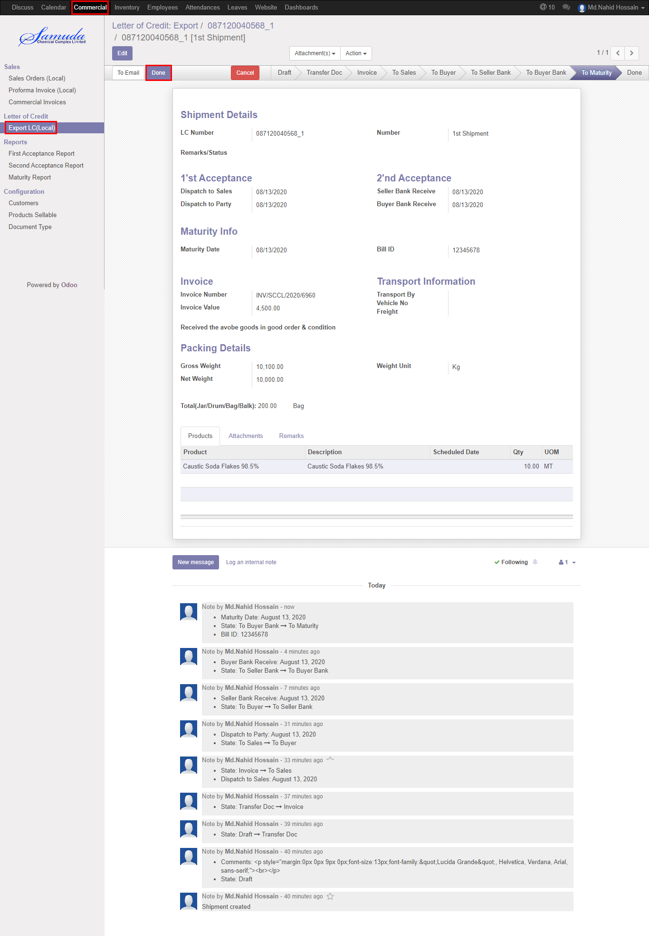

Figure: Done state

After Done Comments window will open then click **save** button then shipment will go done state. 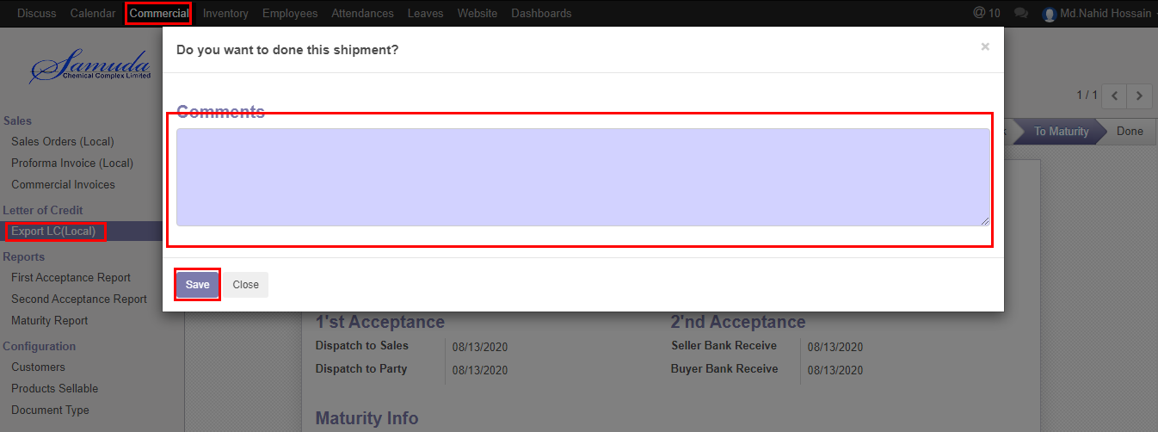

Figure: Comments window

## 2.14 Additional info input by Commercial Manager

Addition info will complete commercial manager if required.

We need to set the following:-

**Landing Port:** Enter landing port.

**Discharge Port:** Enter Discharge port.

**C&F Agent:** Enter C&F agent.

**Insurance Company Name:** Enter Insurance Company Name.

**Insurance Number:** Enter Insurance Number.

**Insurance Bill:** Enter Insurance Bill

After entering all information click **Save**.

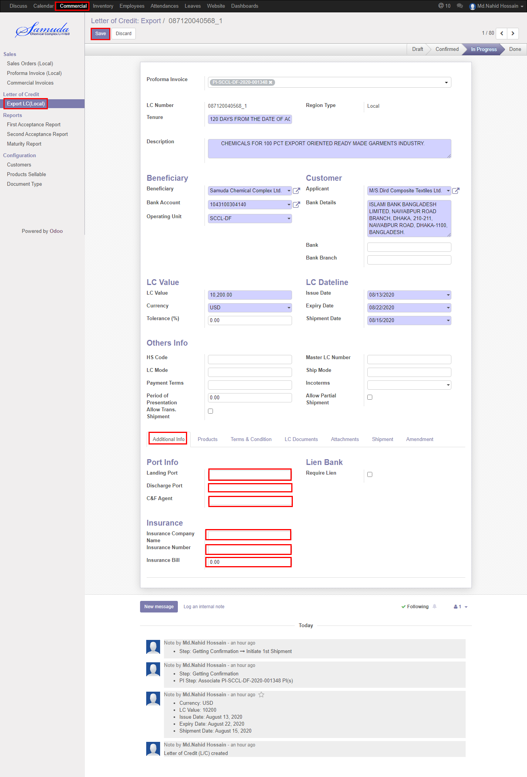

Figure: Additional info

## 2.15 Terms & Condition input by Commercial Manager

Terms & Condition will complete commercial manager if required using terms & condition tab.

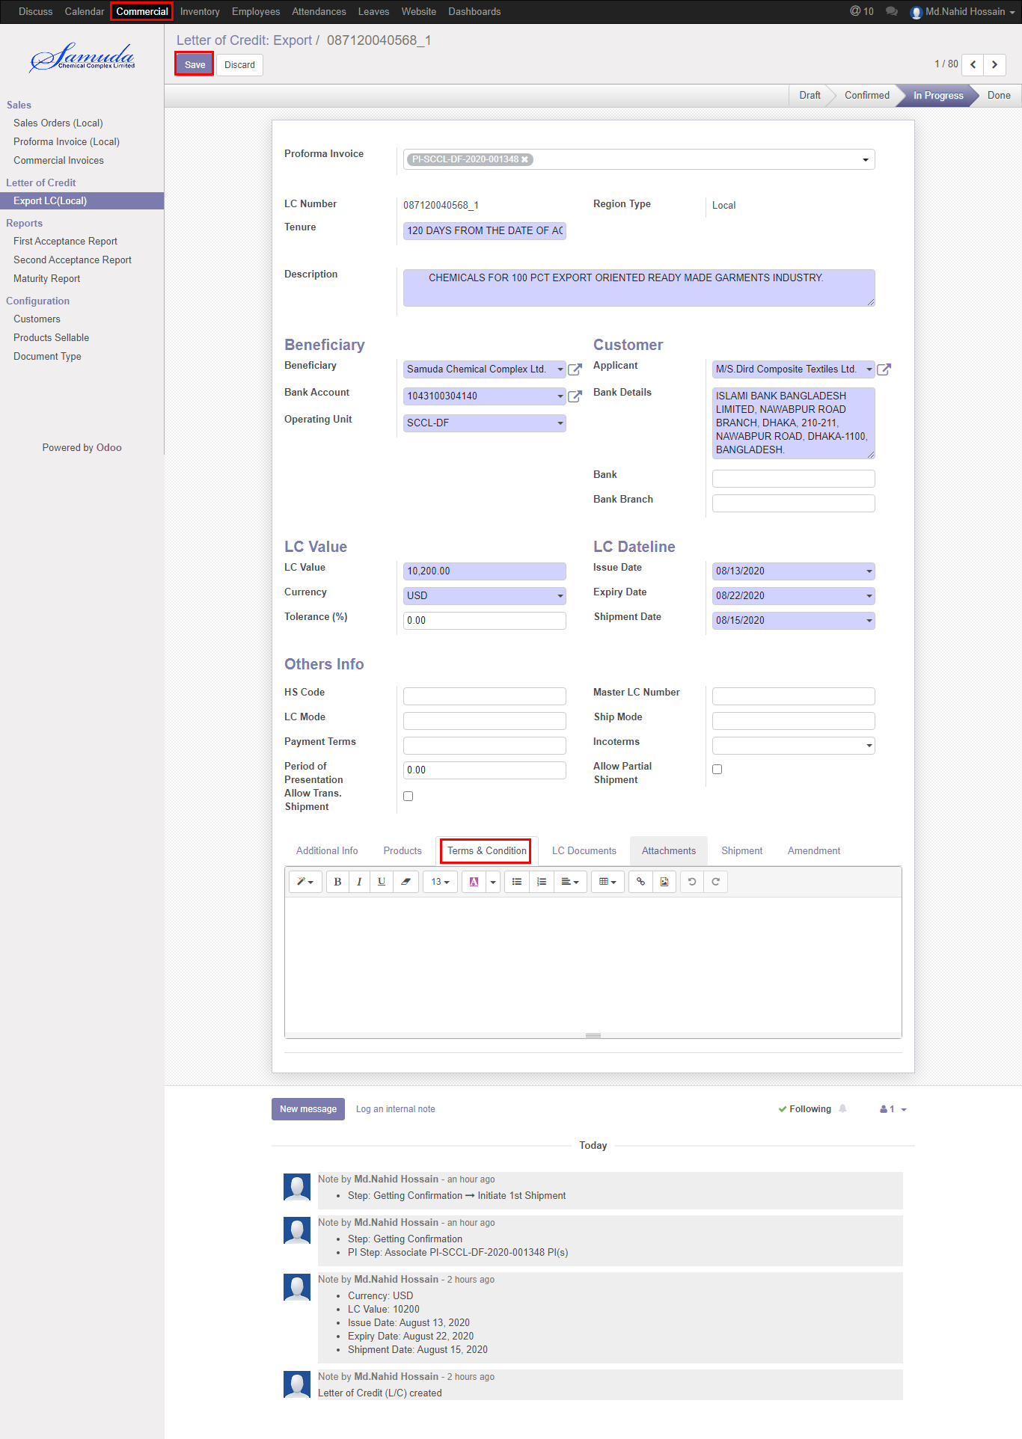

Figure: Terms & Condition

## 2.16 LC document input by Commercial Manager

Terms & Condition will complete commercial manager if required using terms & condition tab.



Figure: Terms & Condition

## 2.17 LC done by Commercial Manager

LC done state will complete when LC against all shipment will done .Commercial Manager LC will done by click **done** button .

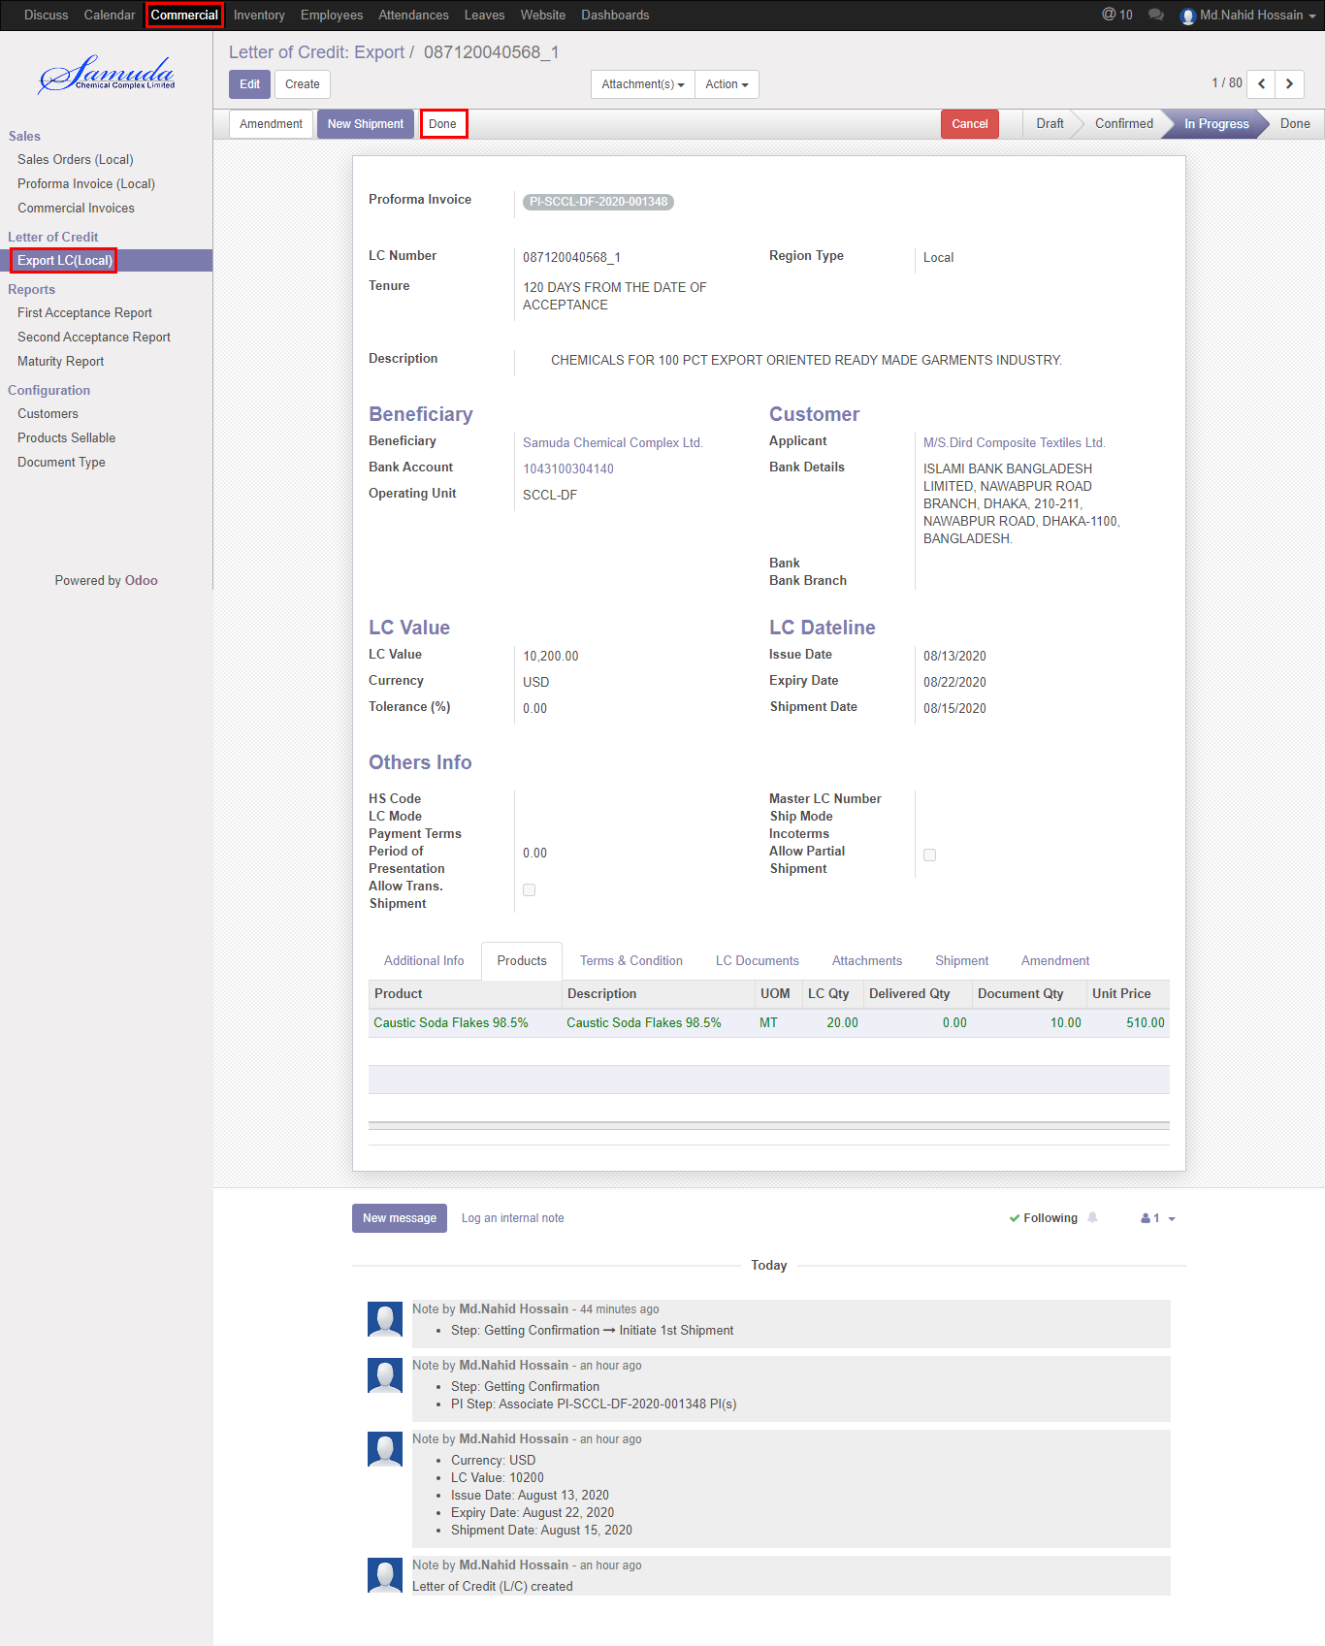

Figure: LC done

# 3. Reports

## 3.1 First Acceptance reports view by Commercial Manager

To see the First Acceptance reports use the menu **Commercial ‣Reports>** **First Acceptance reports**

Select Product thenclick the **Print** button

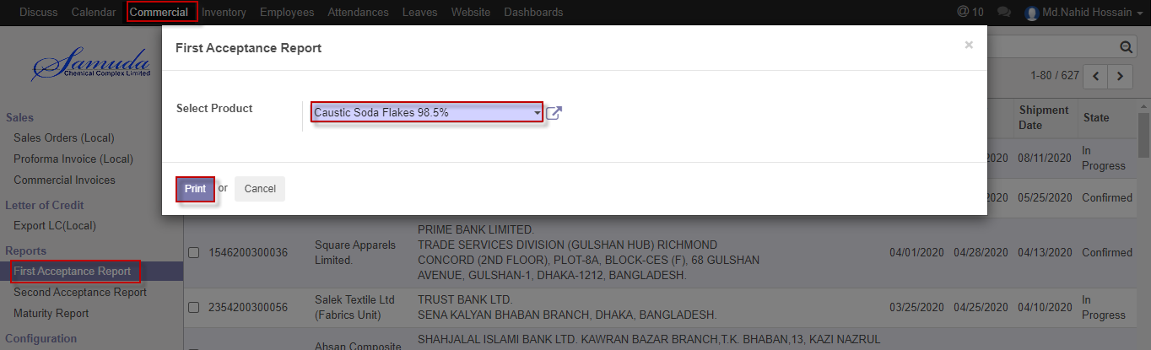

Figure: First Acceptance report print view

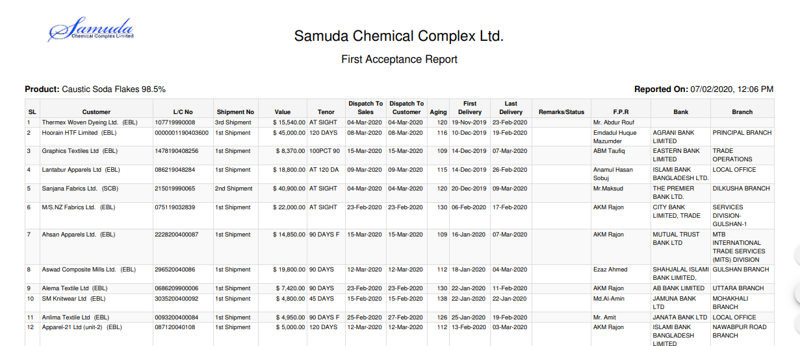

Figure: First Acceptance reports PDF format

## 3.2 Second Acceptance reports view by Commercial Manager

To see the Second Acceptance reports use the menu **Commercial ‣Reports>** **Second acceptance reports**

Select Product thenclick the **Print** button

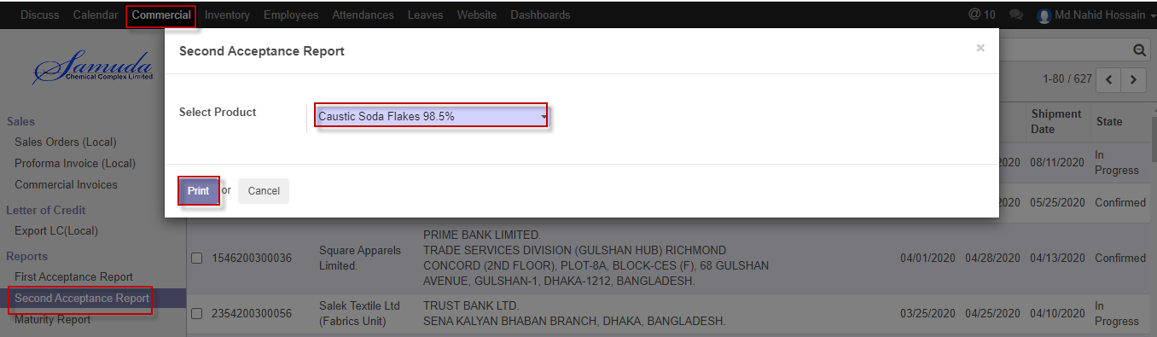

Figure: Second Acceptance report print view

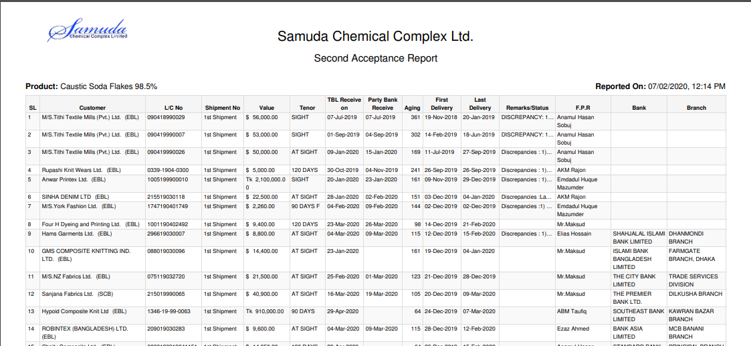

Figure: Second Acceptance reports PDF format

## 3.3 Maturity reports view by Commercial Manager

To see the Maturity reports use the menu **Commercial ‣Reports>** **Maturity**

Select Product thenclick the **Print** button

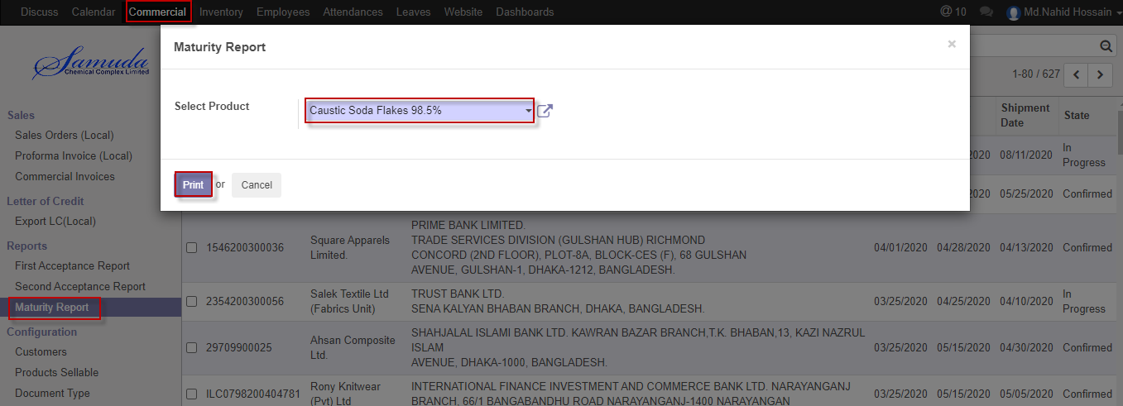

Figure: Maturity report print view

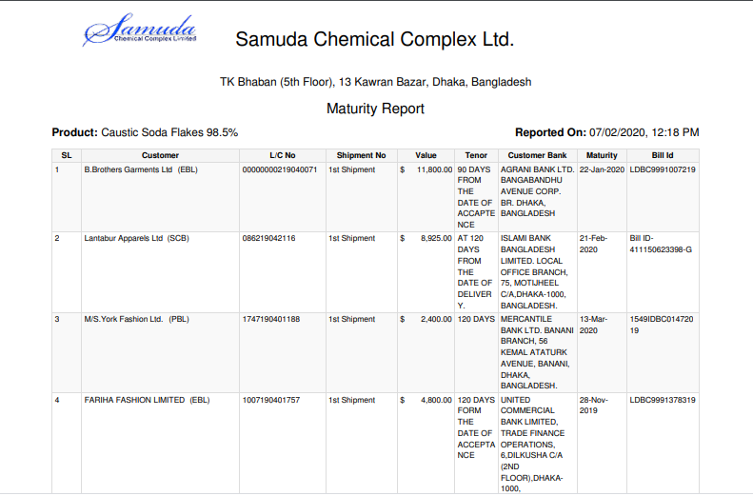

Figure: Maturity reports PDF format

## 3.4 Bank Forwarding reports view by Commercial Manager

To see the Bank forwarding reports use the menu **Commercial ‣Letter of credit ‣Export LC (Local) ‣ Shipment ‣ Action ‣ Print reports ‣ Bank Forwarding**

View Print reports thenclick the **Bank Forwarding** button

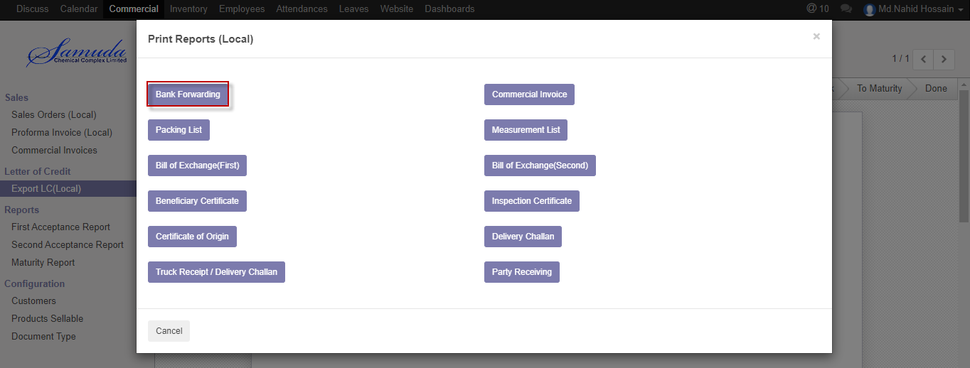

Figure: Bank forwarding reports

## 3.5 Commercial invoice reports view by Commercial Manager

To see the Commercial invoice reports use the menu **Commercial ‣Letter of credit ‣Export LC (Local) ‣ Shipment ‣ Action ‣ Print reports ‣ Commercial invoice**

View Print reports thenclick the **Commercial invoice** button

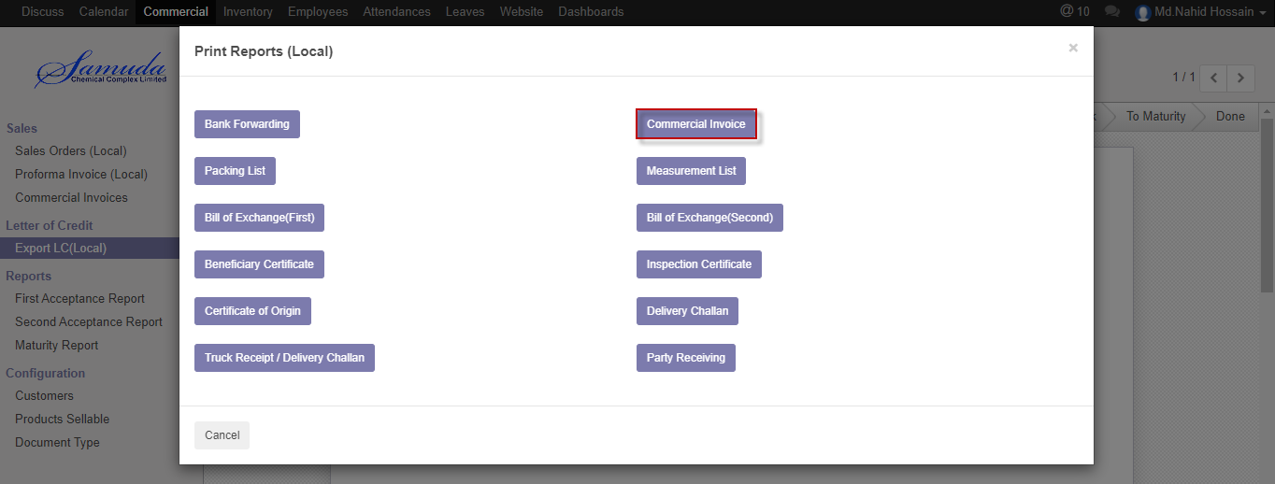

Figure: Commercial invoice reports

## 3.6 Packing list reports view by Commercial Manager

To see the Packing list reports use the menu **Commercial ‣Letter of credit ‣Export LC (Local) ‣ Shipment ‣ Action ‣ Print reports ‣ Packing list**

View Print reports thenclick the **Packing list** button

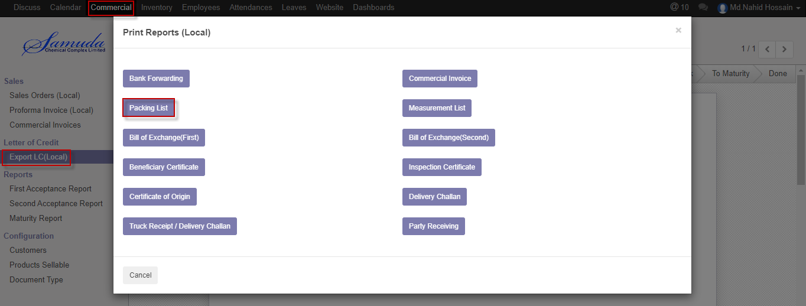

Figure: Packing list reports

## 3.7 Measurement list reports view by Commercial Manager

To see the Measurement list reports use the menu **Commercial ‣Letter of credit ‣Export LC (Local) ‣ Shipment ‣ Action ‣ Print reports ‣ Measurement list**

View Print reports thenclick the **Measurement list** button

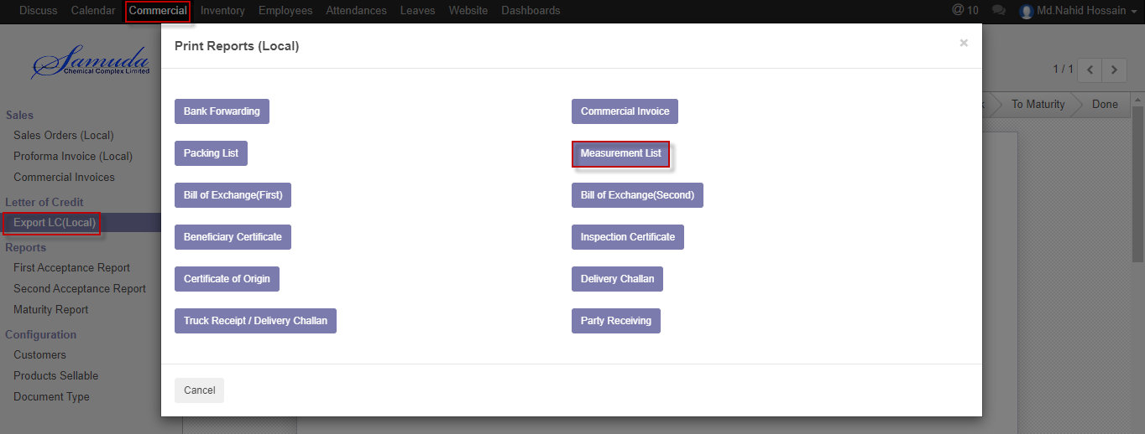

Figure: Measurement list reports

## 3.8 Bill of Exchange (First) reports view by Commercial Manager

To see the Measurement list reports use the menu **Commercial ‣Letter of credit ‣Export LC (Local) ‣ Shipment ‣ Action ‣ Print reports ‣ Bill of Exchange (First)**

View Print reports thenclick the **Bill of Exchange (First)** button

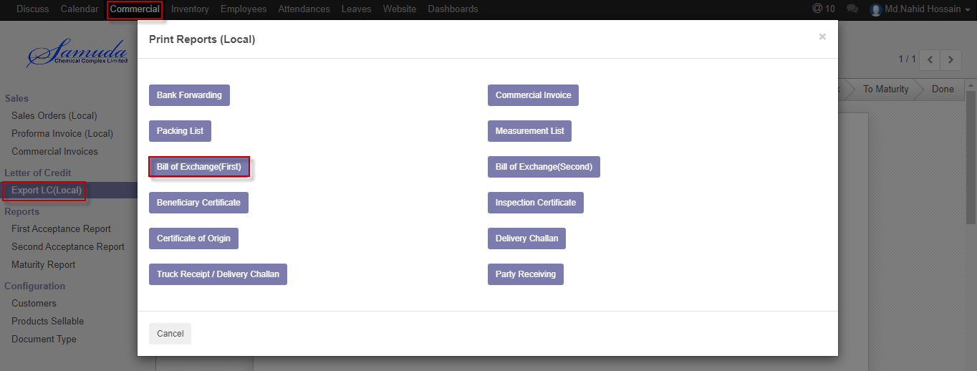

Figure: Bill of exchange (First) reports

## 3.9 Bill of Exchange (Second) reports view by Commercial Manager

To see the Measurement list reports use the menu **Commercial ‣Letter of credit ‣Export LC (Local) ‣ Shipment ‣ Action ‣ Print reports ‣ Bill of Exchange (Second)**

View Print reports thenclick the **Bill of Exchange (Second)** button

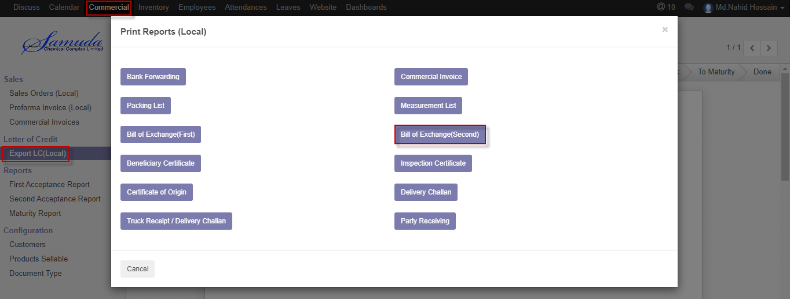

Figure: Bill of exchange (Second) reports

## 3.10 Beneficiary certificate reports view by Commercial Manager

To see the Measurement list reports use the menu **Commercial ‣Letter of credit ‣Export LC (Local) ‣ Shipment ‣ Action ‣ Print reports ‣ Beneficiary certificate**

View Print reports thenclick the **Beneficiary certificate** button

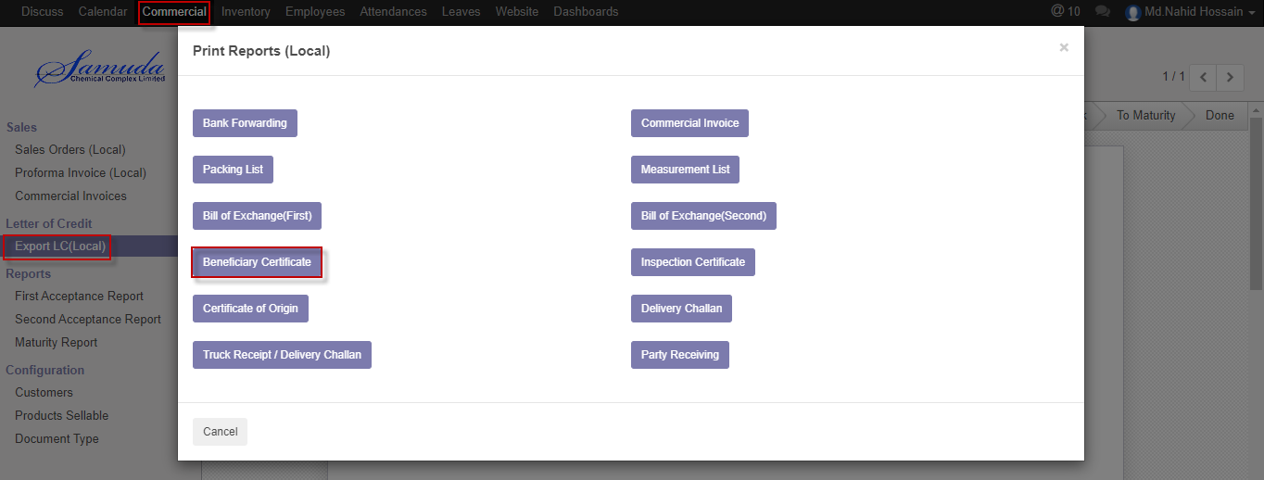

Figure: Beneficiary Certificate reports

## 3.11 Inspection Certificate reports view by Commercial Manager

To see the Measurement list reports use the menu **Commercial ‣Letter of credit ‣Export LC (Local) ‣ Shipment ‣ Action ‣ Print reports ‣ Inspection certificate**

View Print reports thenclick the **Inspection certificate** button

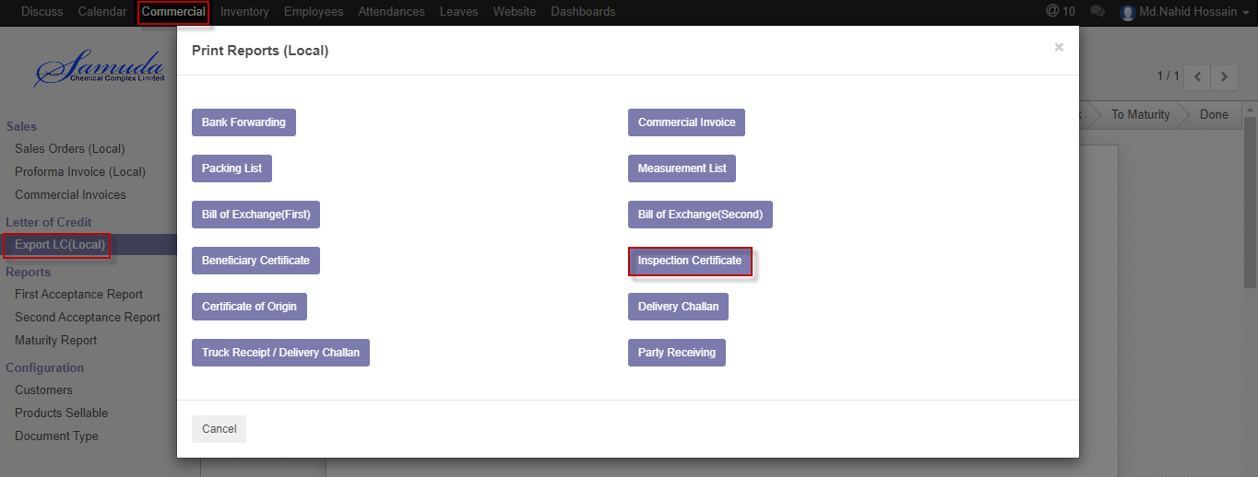

Figure: Inspection Certificate reports

## 3.12 Certificate of Origin reports view by Commercial Manager

To see the Measurement list reports use the menu **Commercial ‣Letter of credit ‣Export LC (Local) ‣ Shipment ‣ Action ‣ Print reports ‣ Certificate of Origin**

View Print reports thenclick the **Certificate of Origin** button

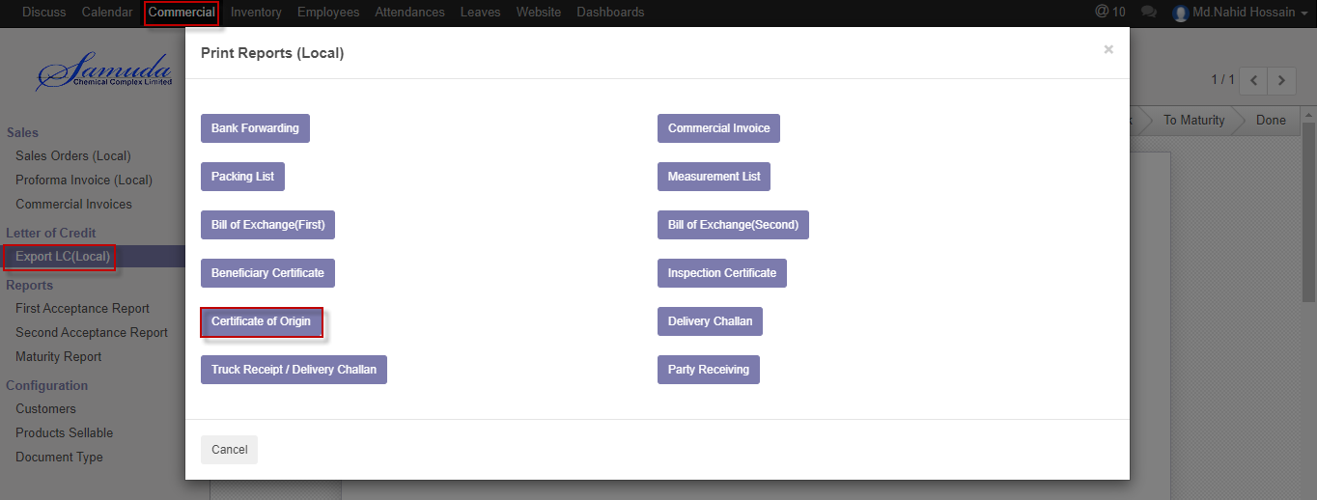

Figure: Certificate of origin reports

## 3.13 Delivery Challan reports view by Commercial Manager

To see the Measurement list reports use the menu **Commercial ‣Letter of credit ‣Export LC (Local) ‣ Shipment ‣ Action ‣ Print reports ‣ Delivery Challan**

View Print reports thenclick the **Delivery Challan** button

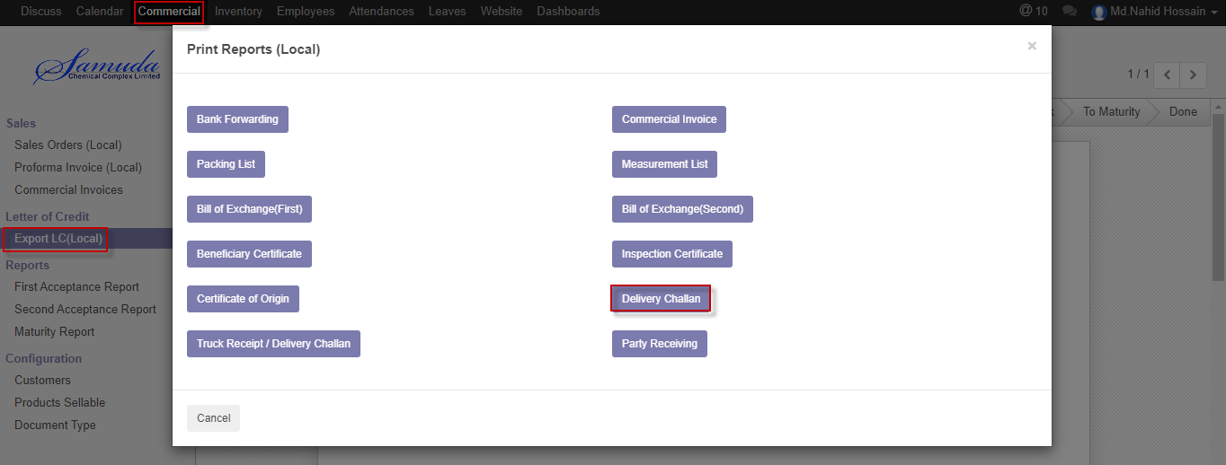

Figure: Delivery challan reports

## 3.14 Truck receipt/Delivery challan reports view by Commercial Manager

To see the Measurement list reports use the menu **Commercial ‣Letter of credit ‣Export LC (Local) ‣ Shipment ‣ Action ‣ Print reports ‣ Truck receipt/Delivery challan**

View Print reports thenclick the **Truck receipt/Delivery challan** button

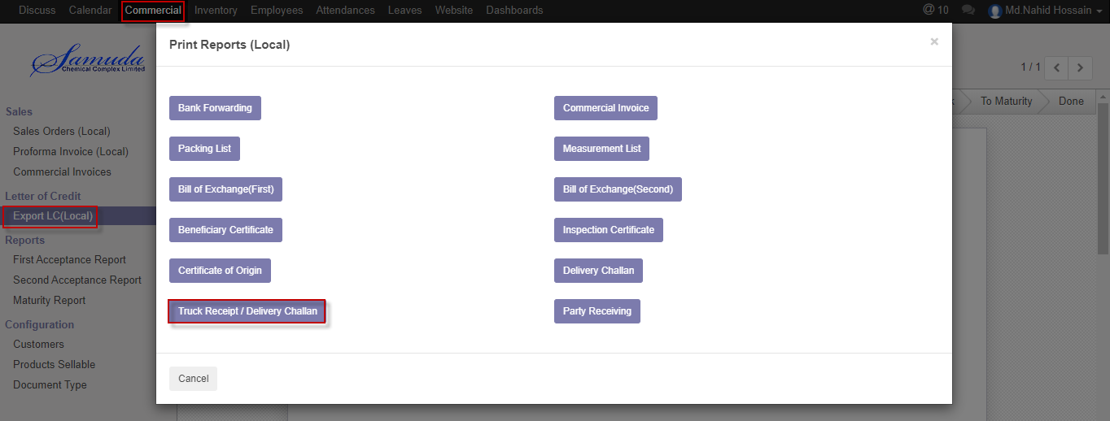

Figure: Truck receipt/Delivery challan reports

## 3.15 Party receiving reports view by Commercial Manager

To see the Measurement list reports use the menu **Commercial ‣Letter of credit ‣Export LC (Local) ‣ Shipment ‣ Action ‣ Print reports ‣ Party receiving**

View Print reports thenclick the **Party receiving** button

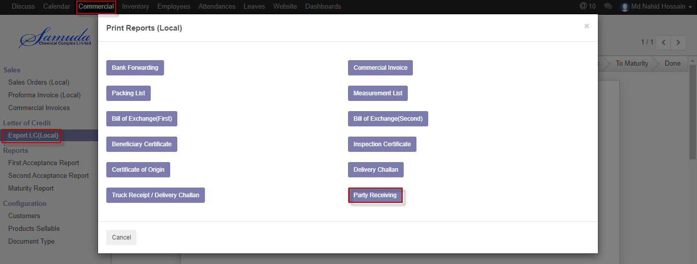

Figure: Party receiving reports